PYTHON ESSENTIALS

In this lecture, we will cover some patterns and techniques that are quite useful when building and testing python based scripts and applications.

**Introduction** **2**

Installing Packages 2

Running Python 2

REPL.it 2

Google Colab 12

Docker 25

Docker Compose and Jupyter Notebook 28

**Generators** **31**

**Concurrency** **41**

# 

# 

# 

# 

# 

# 

# 

# 

# 

# Introduction

In this section, we will cover some basic know-how for how to run python and best practices around running python code in a reliable manner.

## Installing Packages

There are several ways we can run python programs. Generally, a python program is not run by itself, but rather using libraries or modules that make it much easier to perform the task at hand. Some libraries are packaged with python by default. These can be accessed anywhere python is installed. Others must be downloaded and configured such that they are accessible.

Python maintains an “official” repository of packages, called **PyPI**: Python Package Index. Click [**here**](https://pypi.org/)to access the website. A “package” is simply a collection of python files that work together to do something. It can be thought of as a collection of classes and functions that work together to make a certain task useful. All packages that are published to PyPI can be automatically installed into a python project using **pip**.

**Pip** is a command line tool that comes built in with python. With pip, any package that is available in PyPI can be installed into your python project using a simple command line utility:

pip install <package-name>

This will download the necessary files to your computer (or docker environment) and allow your code to easily access the functions and classes it provides. Typically, in your code, you would run something like this to access a package you installed via pip:

|  |
| --- |
| **from** packge_name **import** some_class, some_function |

To understand what classes or functions a package provides, you must visit the package home page for documentation and further instructions.

Before looking at examples of how to install and use packages, let us examine what options we have for running python code.

## Running Python

There are several ways to run python code - either in a local environment or on the “cloud”. There are advantages and disadvantages to all approaches and generally, choosing the best environment for working on python depends on the particular usecase more than anything else.

### **REPL.it**

[**REPLit**](https://repl.it/)is a free online platform for writing and running code. Generally speaking, it is quite powerful in that it offers the user to write code in various different languages in a “real” environment.

When it comes to spot checking a small piece of code or sharing a code sample that actually runs, REPL is a great choice.

This service is a “freemium” model, meaning that the free version is fairly solid and useful but lacks certain key features - such as storage and CPU power. Again, do not use REPL to write full blown programs. Instead, leverage it to quickly check concepts without having to open a terminal.

Also - REPL just introduced the ability to directly clone and run Github Repos. This new feature is fairly promising but also still in the early stages. Definitely worth watching the evolution of this service as it holds a lot of potential.

Installing packages in REPL is *very* easy and intuitive. Just visit the PyPI page for the package, look at an example for how to import and paste that into your REPL code environment. If you are running your code for the first time, REPL will intelligently download the requisite packages for you.

For instance, let’s consider [the **requests** module from PyPI](https://pypi.org/project/requests/).

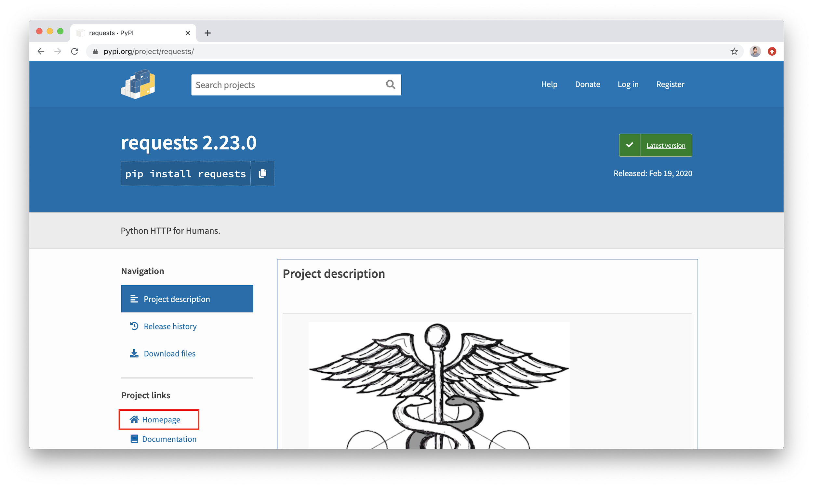

While there is definitely some minimal documentation available on the PyPI homepage, it is best to visit the package “homepage” as noted on the left side of the image above to get the “full” documentation set.

Typically, documentation will contain both “quickstart” guides *and* a deeper look at how the code is structured, built and which features can be overridden or modified for your particular needs.

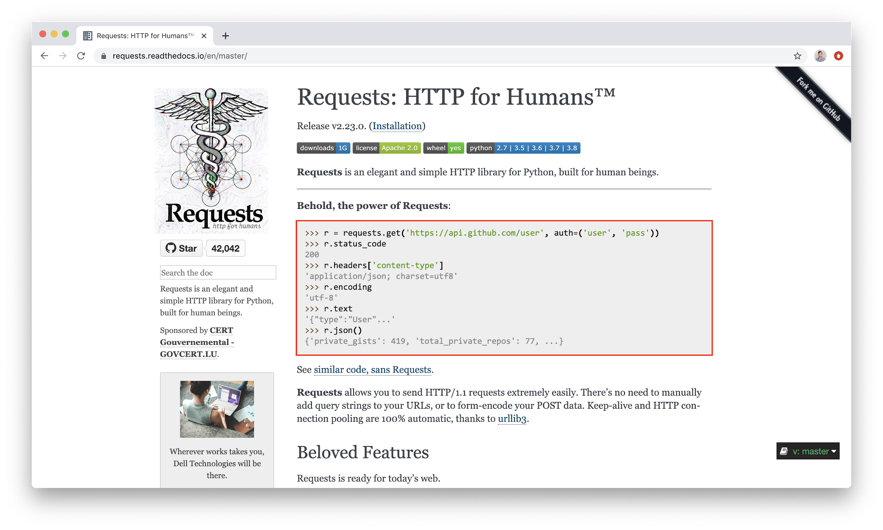

Given the starter code above, we can plug into REPL to see this in action. First, create a new REPL. (You don’t need to be signed in to use this service however if you do sign in, you’ve the ability to save your code and pick it up again later).

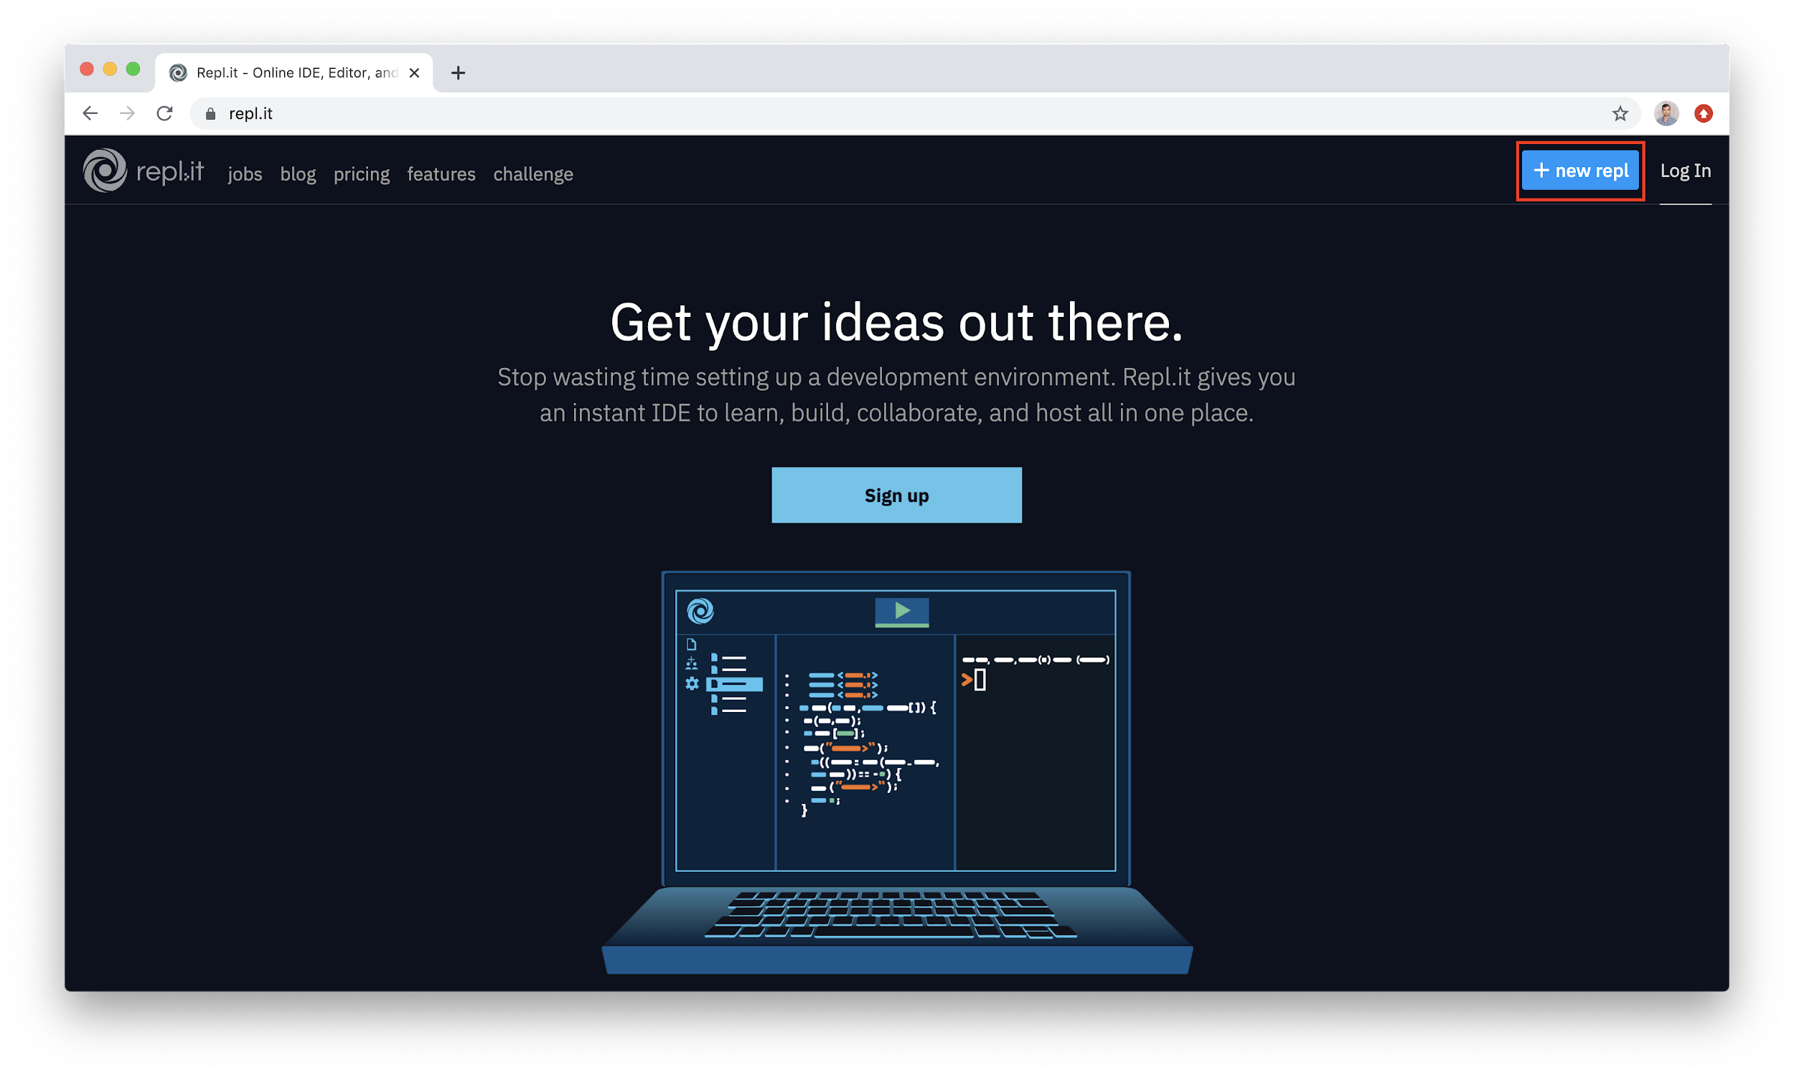

Obviously, choose “Python” for programming language. (NOTE: “Python” refers to Python3 - if you need Py2.7 for any reason, type in the entire word and it should become available as an option - at least for now).

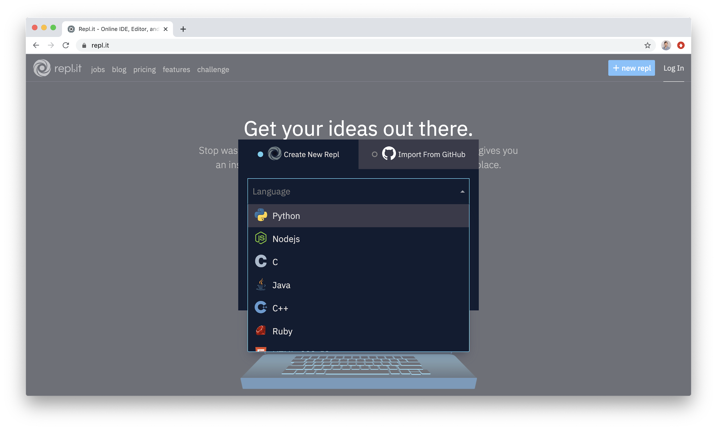

Once the REPL env have been created, you should end up on a page that looks like this:

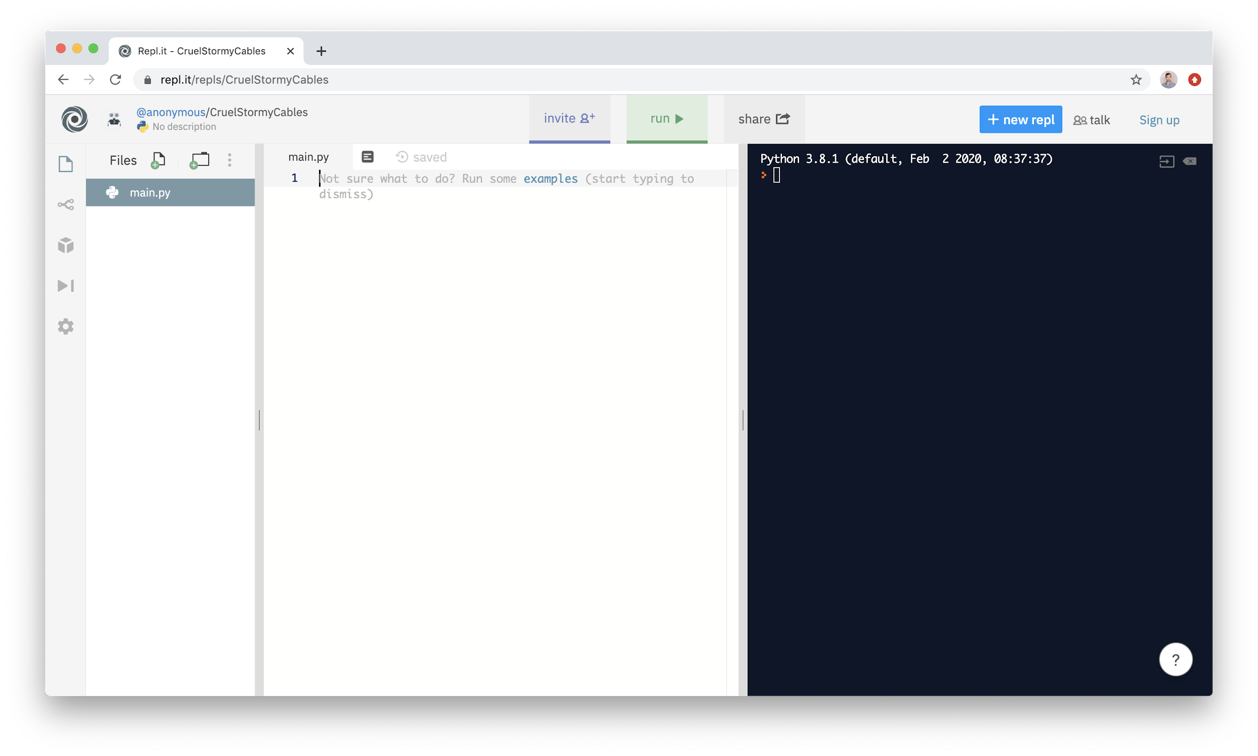

Running code here is self-explanatory. Let’s begin by pasting in the example from the **requests** module (slightly modified as it requires a password):

|  |
| --- |
| **import** requests  # this is a "get" request - try pasting into your browser URL r = requests.get('https://api.github.com/users/mottaquikarim')  # this is the status code, 200 means "successful" print(r.status_code))  # this is a hint for what type of content we expect to get back # application/json implies it is encoded as a data structure print(r.headers['content-type'])  # print the actual response print(r.json()) |

We simply paste this into REPL.it and run:

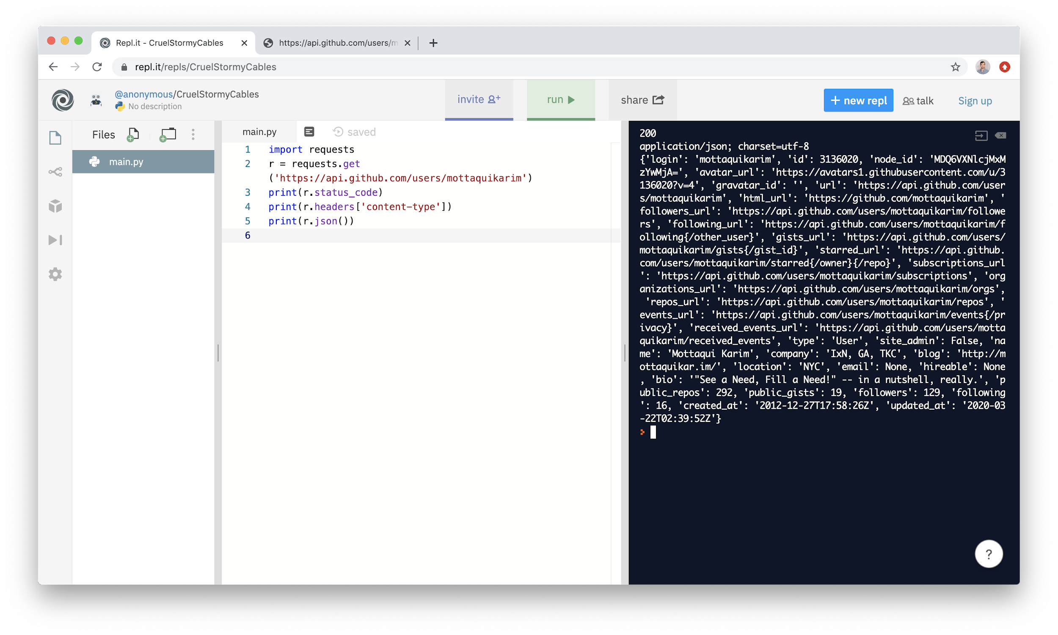

And that’s it! It *just* works. On the right hand side is the output you would expect to see in a real terminal have you run this code via the command line.

One additional note: you have the ability to create multiple folders and files in REPL as well. The following screenshots demonstrate this:

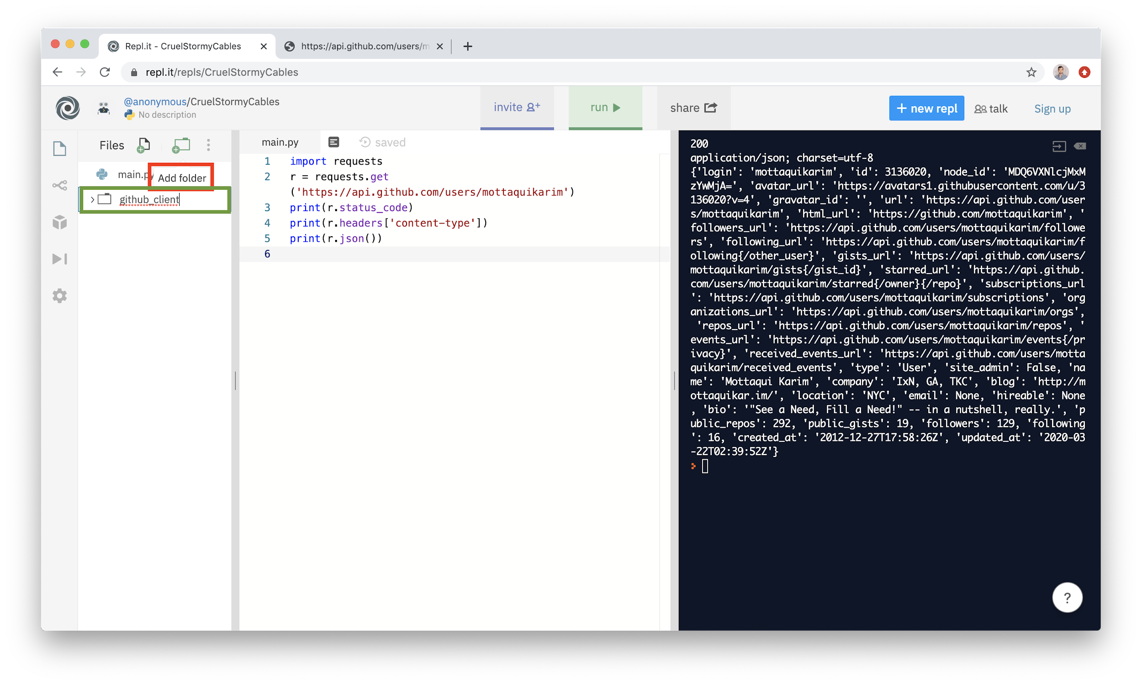

You can call your folder whatever you like, just as you would in a normal python program created via terminal. It is worth noting that file names should never have dashes or spaces.

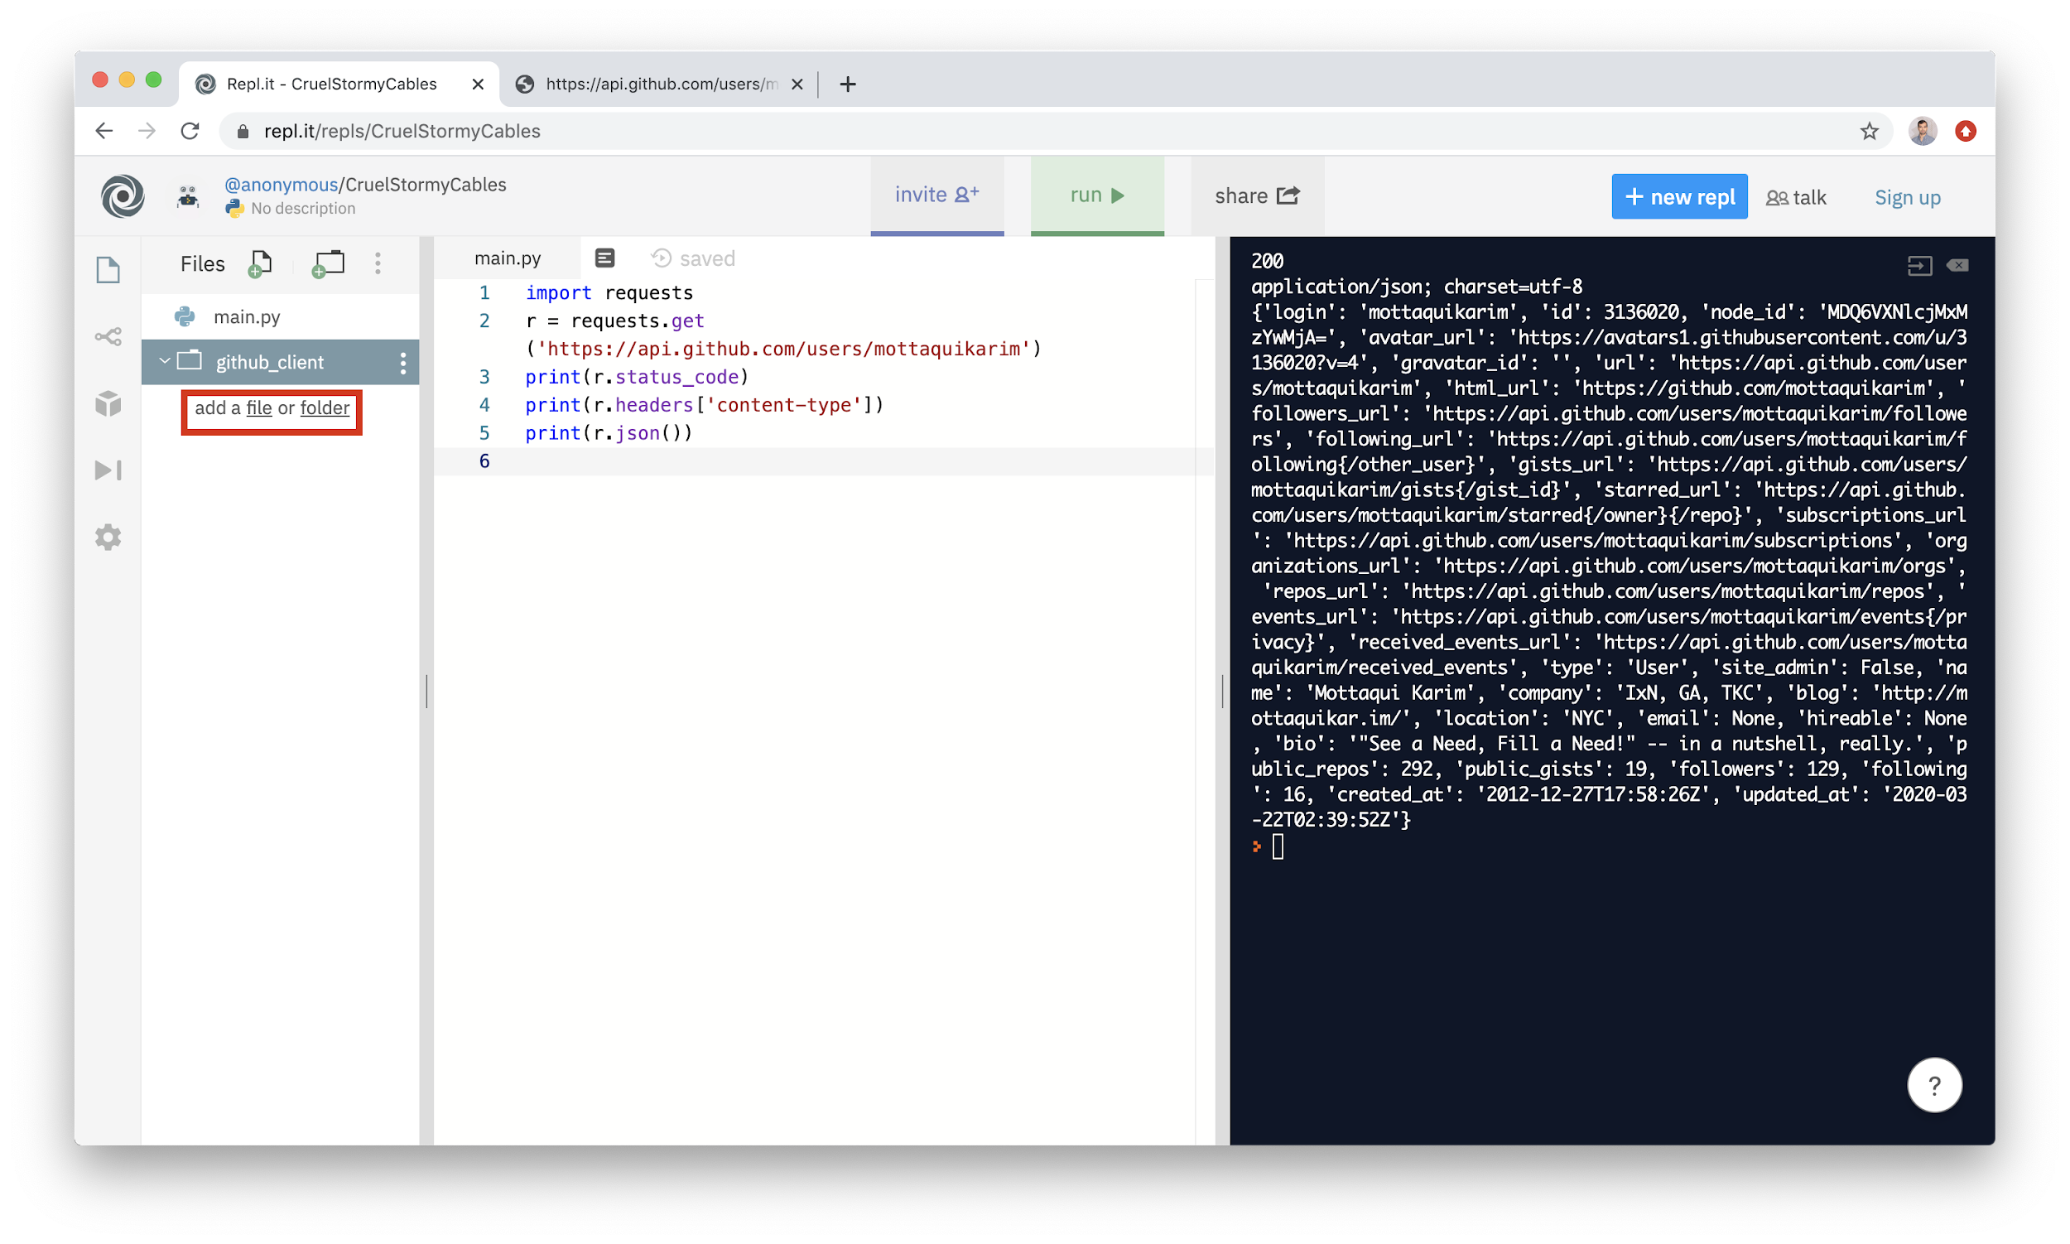

Within a folder, you are able to create as many files you like. For the purposes of this example, we are creating a folder called **github_client** which will contain functions that can be used to interact with the Github API. Our folder structure now looks like this:

|  |
| --- |
| **main.py**  **github_client/**  **__init__.py**  **conf.py** |

In REPL, the corresponding folder structure:

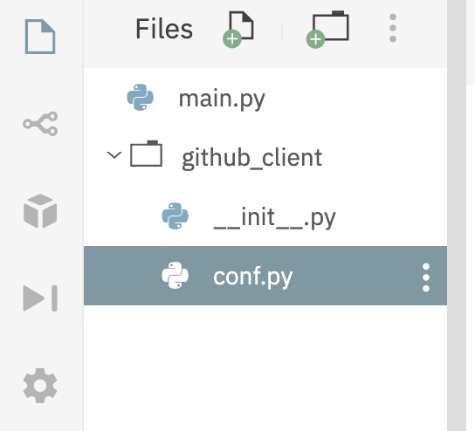

Now, let’s begin by examining the files in the **github_client** folder:

**__init__.py**

|  |
| --- |
| **import** requests  **from** github_client.conf **import** API_BASE  **def** **get_user**(username):  """Get user data from API"""  r = requests.get(f"{API_BASE}/users/{username}")  **return** r.status_code, r.json() |

In REPL:

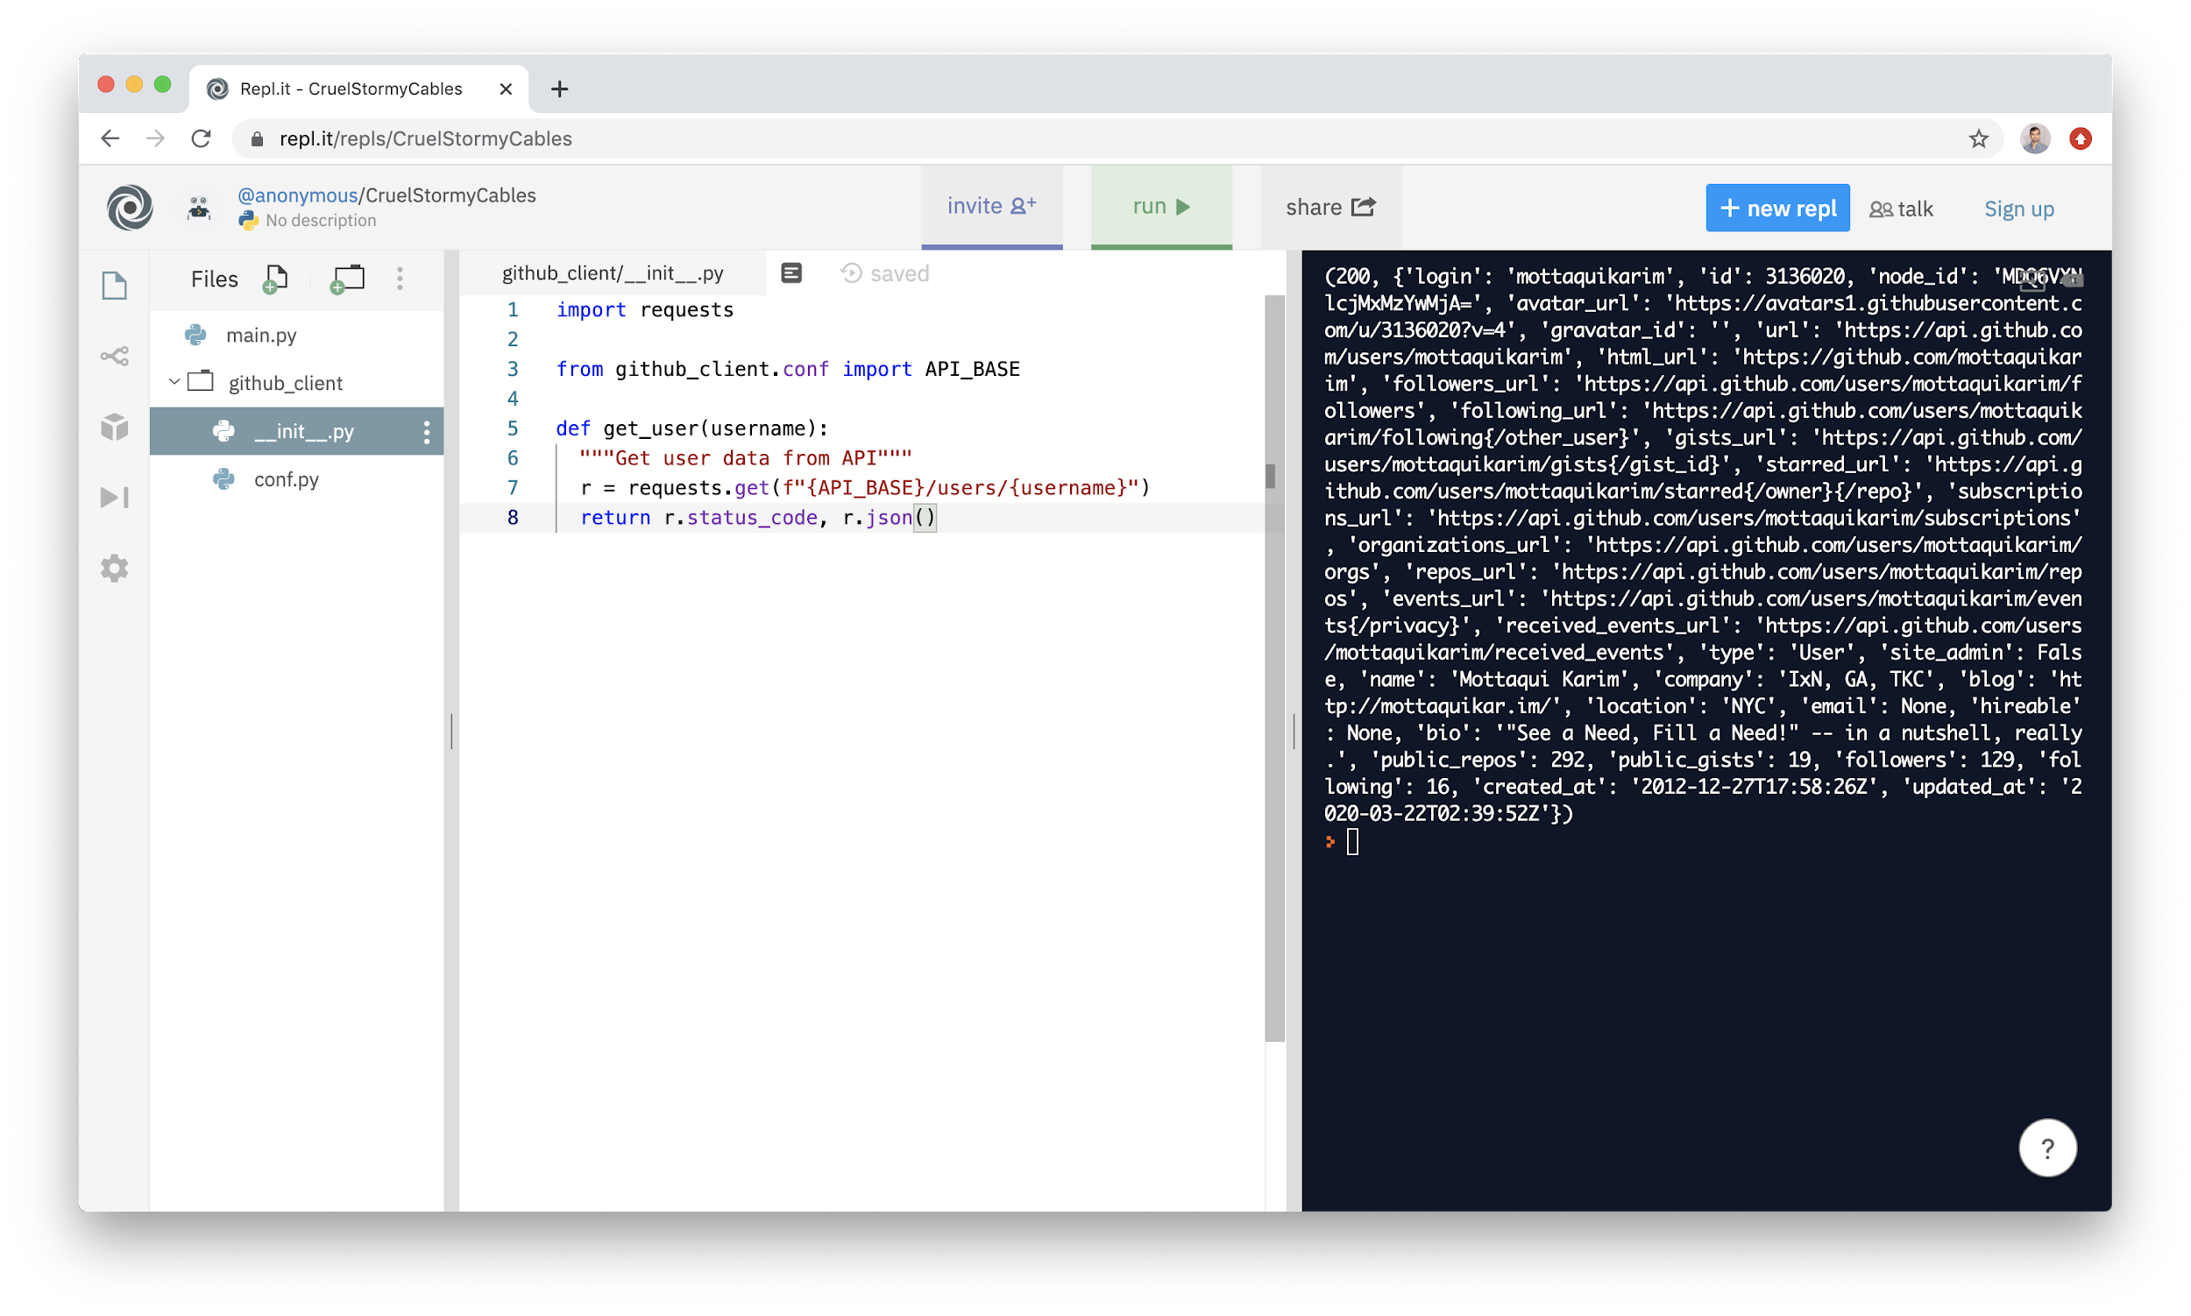

This script creates a function that manages the act of calling the **requests** module to access user information - we did this in a few lines in our initial **main**.py but here we are creating an **abstraction** to make the reuse of this code simpler.

Note the following line:

|  |
| --- |
| **from** github_client.conf **import** API_BASE |

This line is pointing to the *other* file in our folder, **conf.py**, which will contain constants that are often reused, such as the API base url ([**https://api.github.com**](https://api.github.com)). This is good practice in the event we ever need to upgrade API versions or something to that effect. To that end, **conf.py** is exceedingly simple:

**conf.py**

|  |
| --- |
| **API_BASE = 'https://api.github.com'** |

**NOTE**: that to use `conf.py` we had to still point to **github_client.conf**. In REPL:

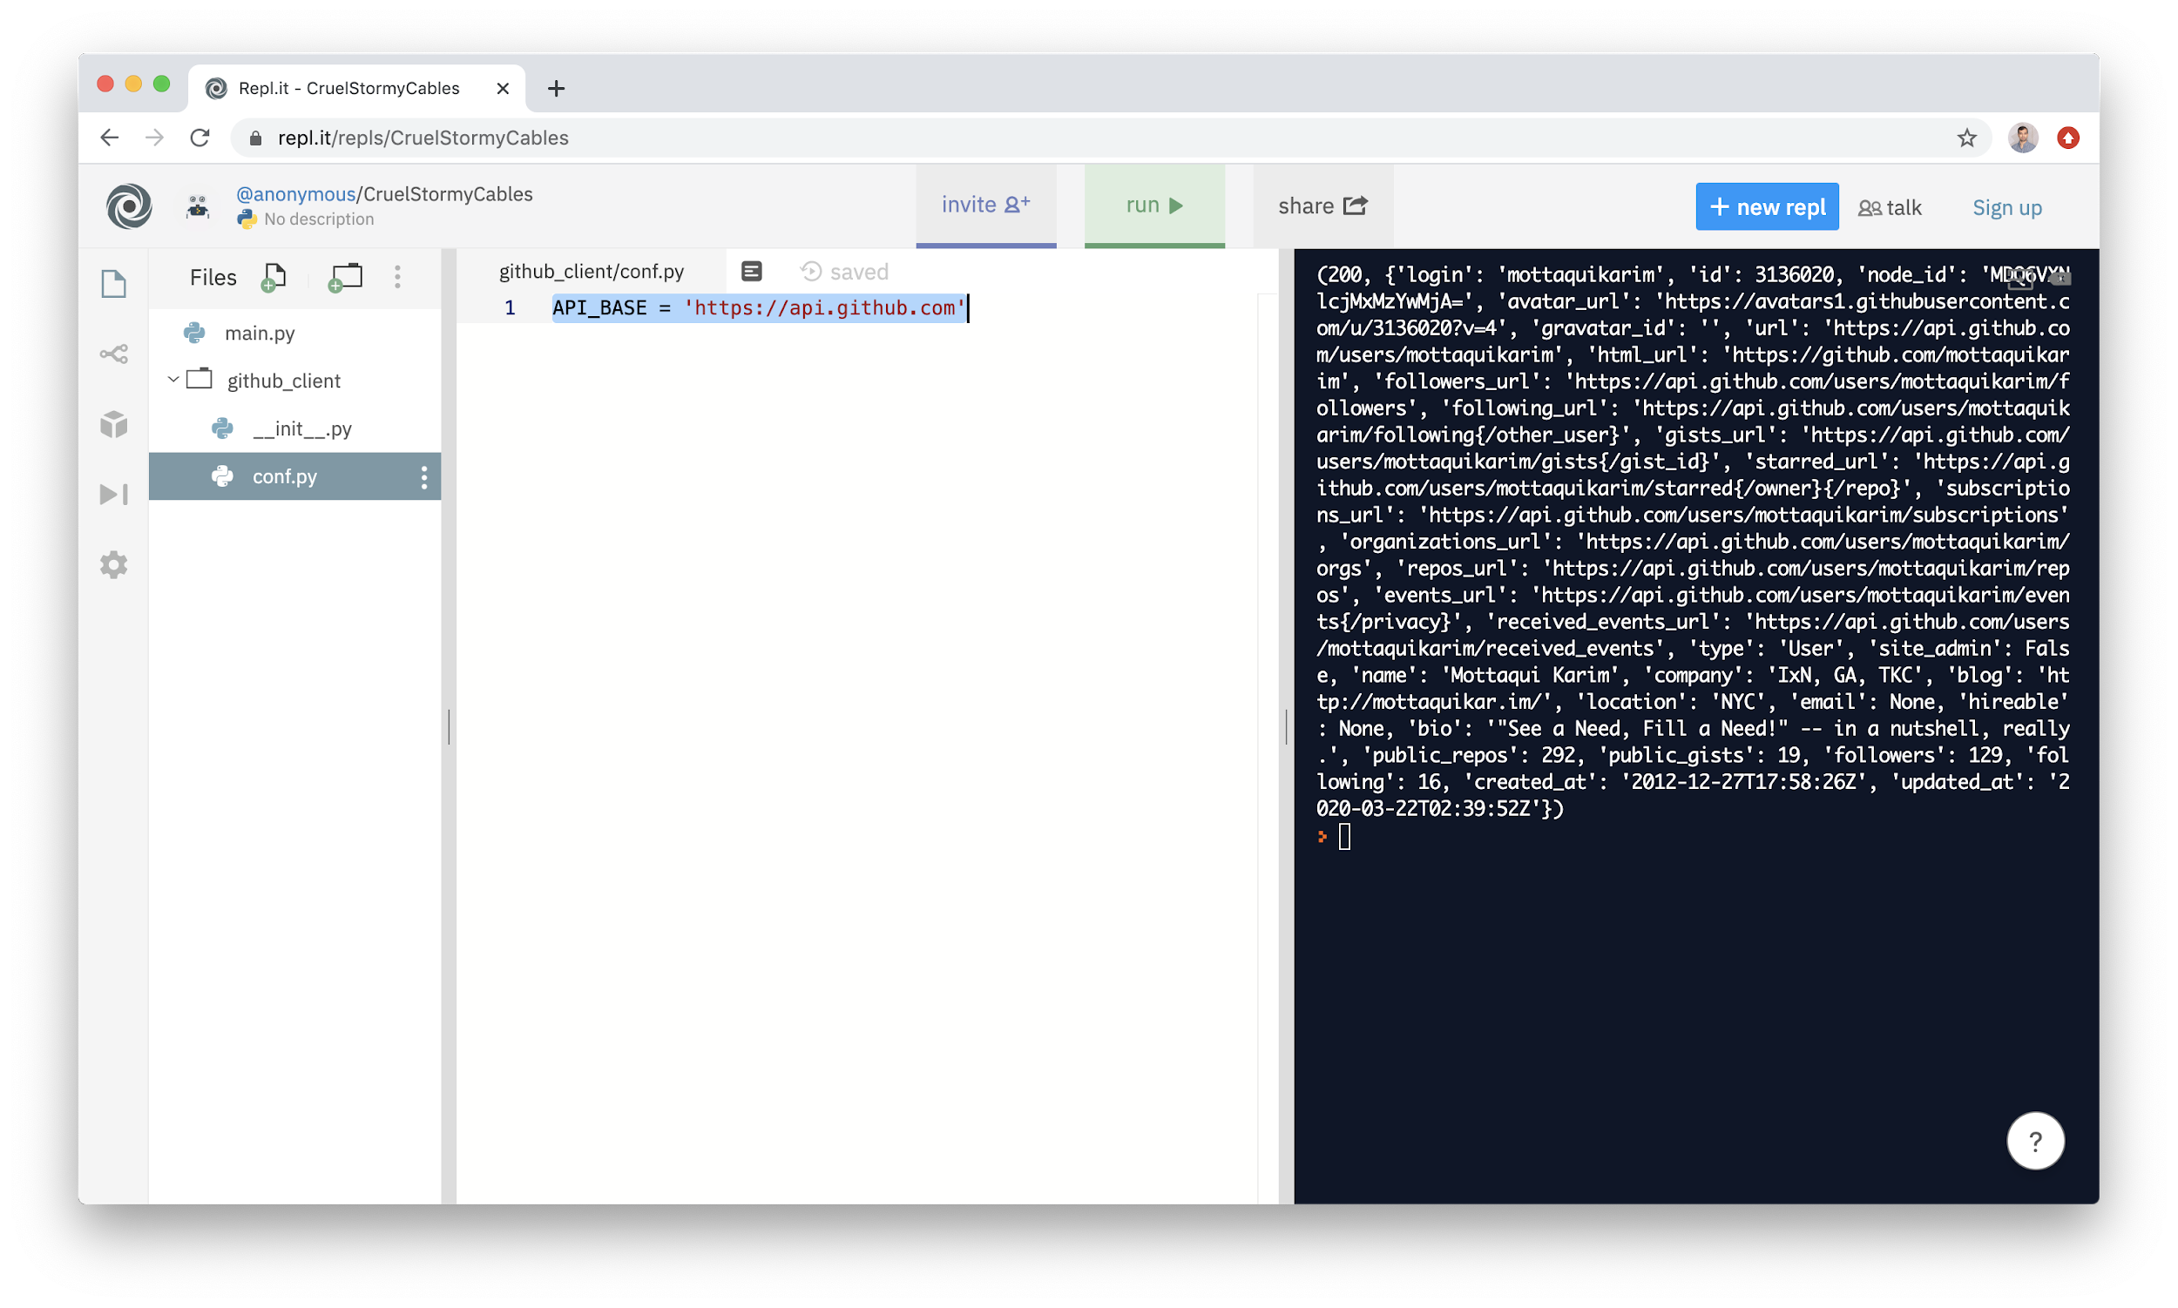

Finally, having built out our code pieces, we can now use it in **main**:

**main.py**

|  |
| --- |
| **from** github_client **import** get_user  print(get_user("mottaquikarim")) |

Main becomes exceedingly simple - which is the point. Generally, we want to write our code such that main.py simply demonstrates the individual high level or key steps that a script is taking to run. The actual minutia of *how* these steps are carried out are generally better “hidden” within function abstractions mainly so that:

* They are reusable across other usecases
* They hide the multiple steps that are needed to perform that action - these steps are important to know and understand but ultimately unnecessary to understanding what the main script is doing and therefore best “obscured:” within a function call

In REPL this is simply:

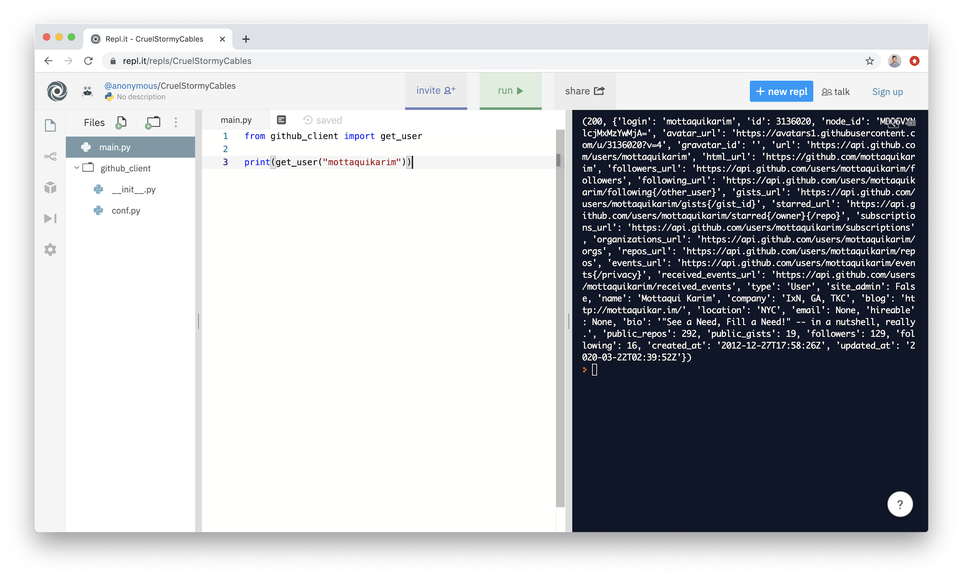

It is also super important to note that in REPL, *only* code written in **main** is actually run. So if you deleted **main** and had a different filename and tried to run it, the output may not actually show up. **This is a limitation of REPL**, likely a bug. Just wanted to point out.

[**Github repo with the code for this portion.**](https://github.com/mottaquikarim/STA9760_github_client)

### **Google Colab**

[**Google Colab**](https://colab.research.google.com/notebooks/intro.ipynb) is an “online” Jupyter Notebook service that allows you to write and run python programs directly against Google’s servers. (NOTE: it is not a Jupyter *clone*, so some of the UI elements and features are a tad different). Colab is great for leveraging python for data analysis type projects - particularly using Pandas.

Google Colab is **awesome**. It allows users to create and save **IPython Notebooks** (**.ipynb** files - the format that Jupyter Notebooks save into) to **Drive** itself. Because these artifacts are simply **.ipynb** files, they can be downloaded and run in any Jupyter Notebook environment. Moreover, Colab supports saving directly to Github, which is very nice as Github actually renders **.ipynb** notebooks, making this a great way to share analysis created and run in Colab.

Finally, Colab will *automatically* install pip modules the first time they are referenced, which is super useful and user friendly.

Let’s now take a look at how we could run our requests module implementation in Colab. First, go to [**https://colab.research.google.com/**](https://colab.research.google.com/)**.** You will need to go to **File > New Notebook** to get started.

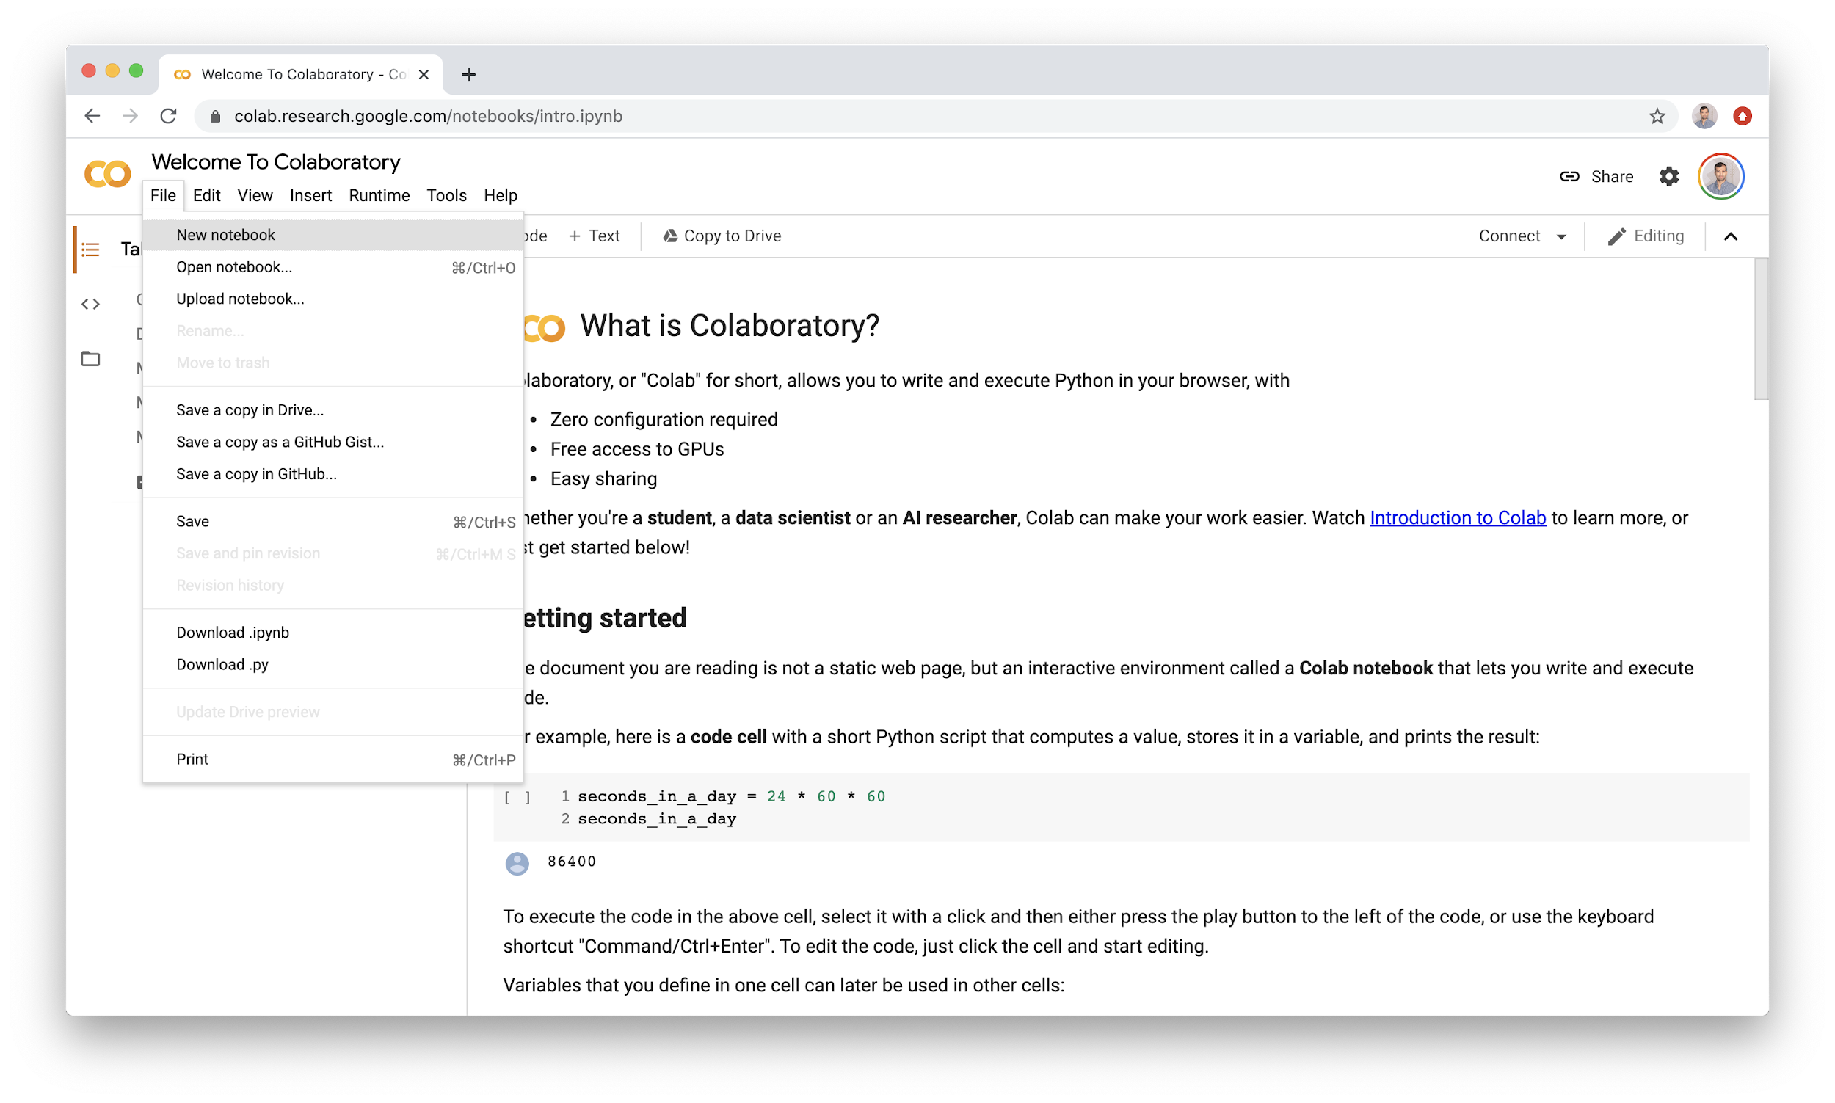

Then, rename your notebook to something more pertinent:

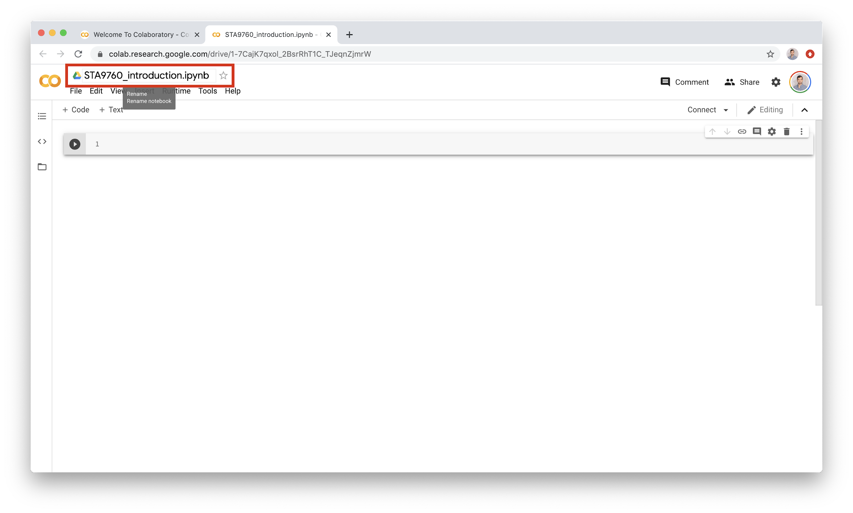

(Your notebooks can be found in your Google Drive, under “Colab Notebooks”. Of course, you can just search for the title, all the more reason to rename your notebook). The beauty of notebooks is that it is possible and encouraged to annotate your “code blocks” with actual text, written in [**markdown**](https://guides.github.com/features/mastering-markdown/). (If you don’t know markdown, it is highly recommended that you learn it - it is quite simple to pick up and most professional environments use it in some way shape or form).

Leveraging the annotation features of colab, you might want to end up with something like this:

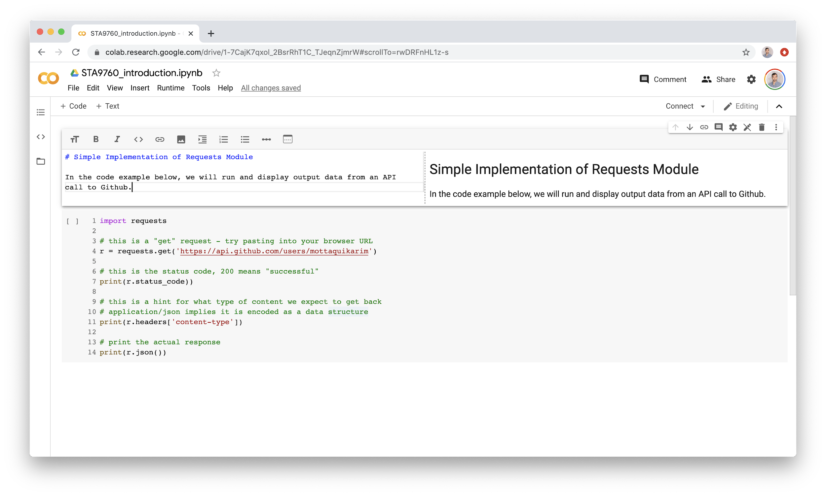

Rendered and run, the notebook now looks like this:

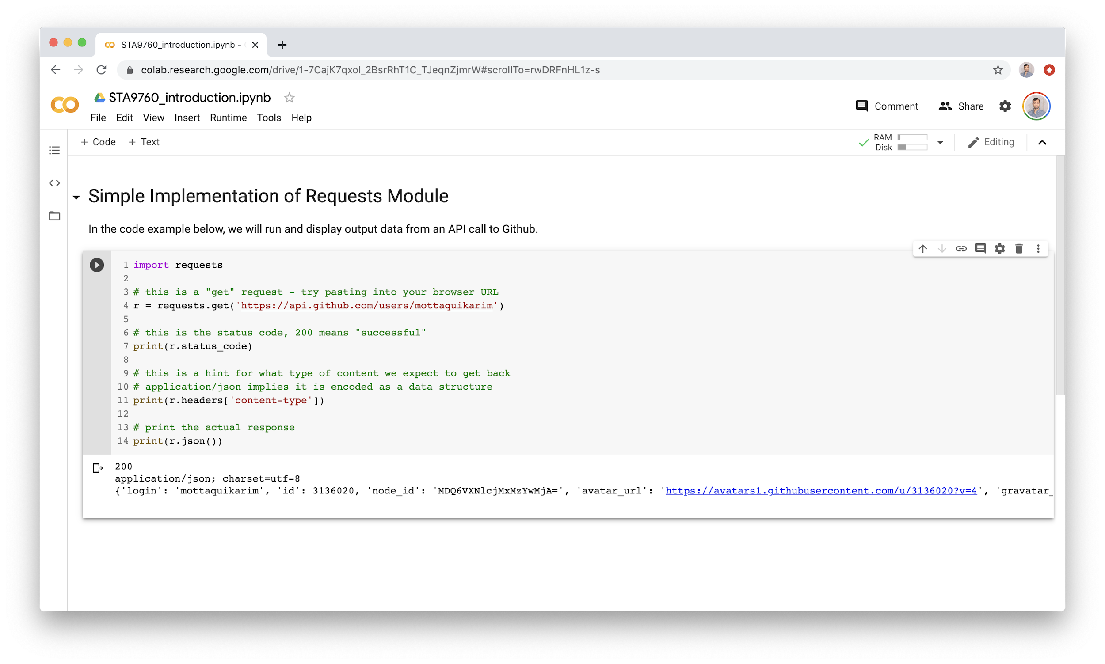

Generally, when working with notebooks, it is preferred to create a single cell with the line of code we want to print - vs wrapping in **print** statement. Applying this principle, we have:

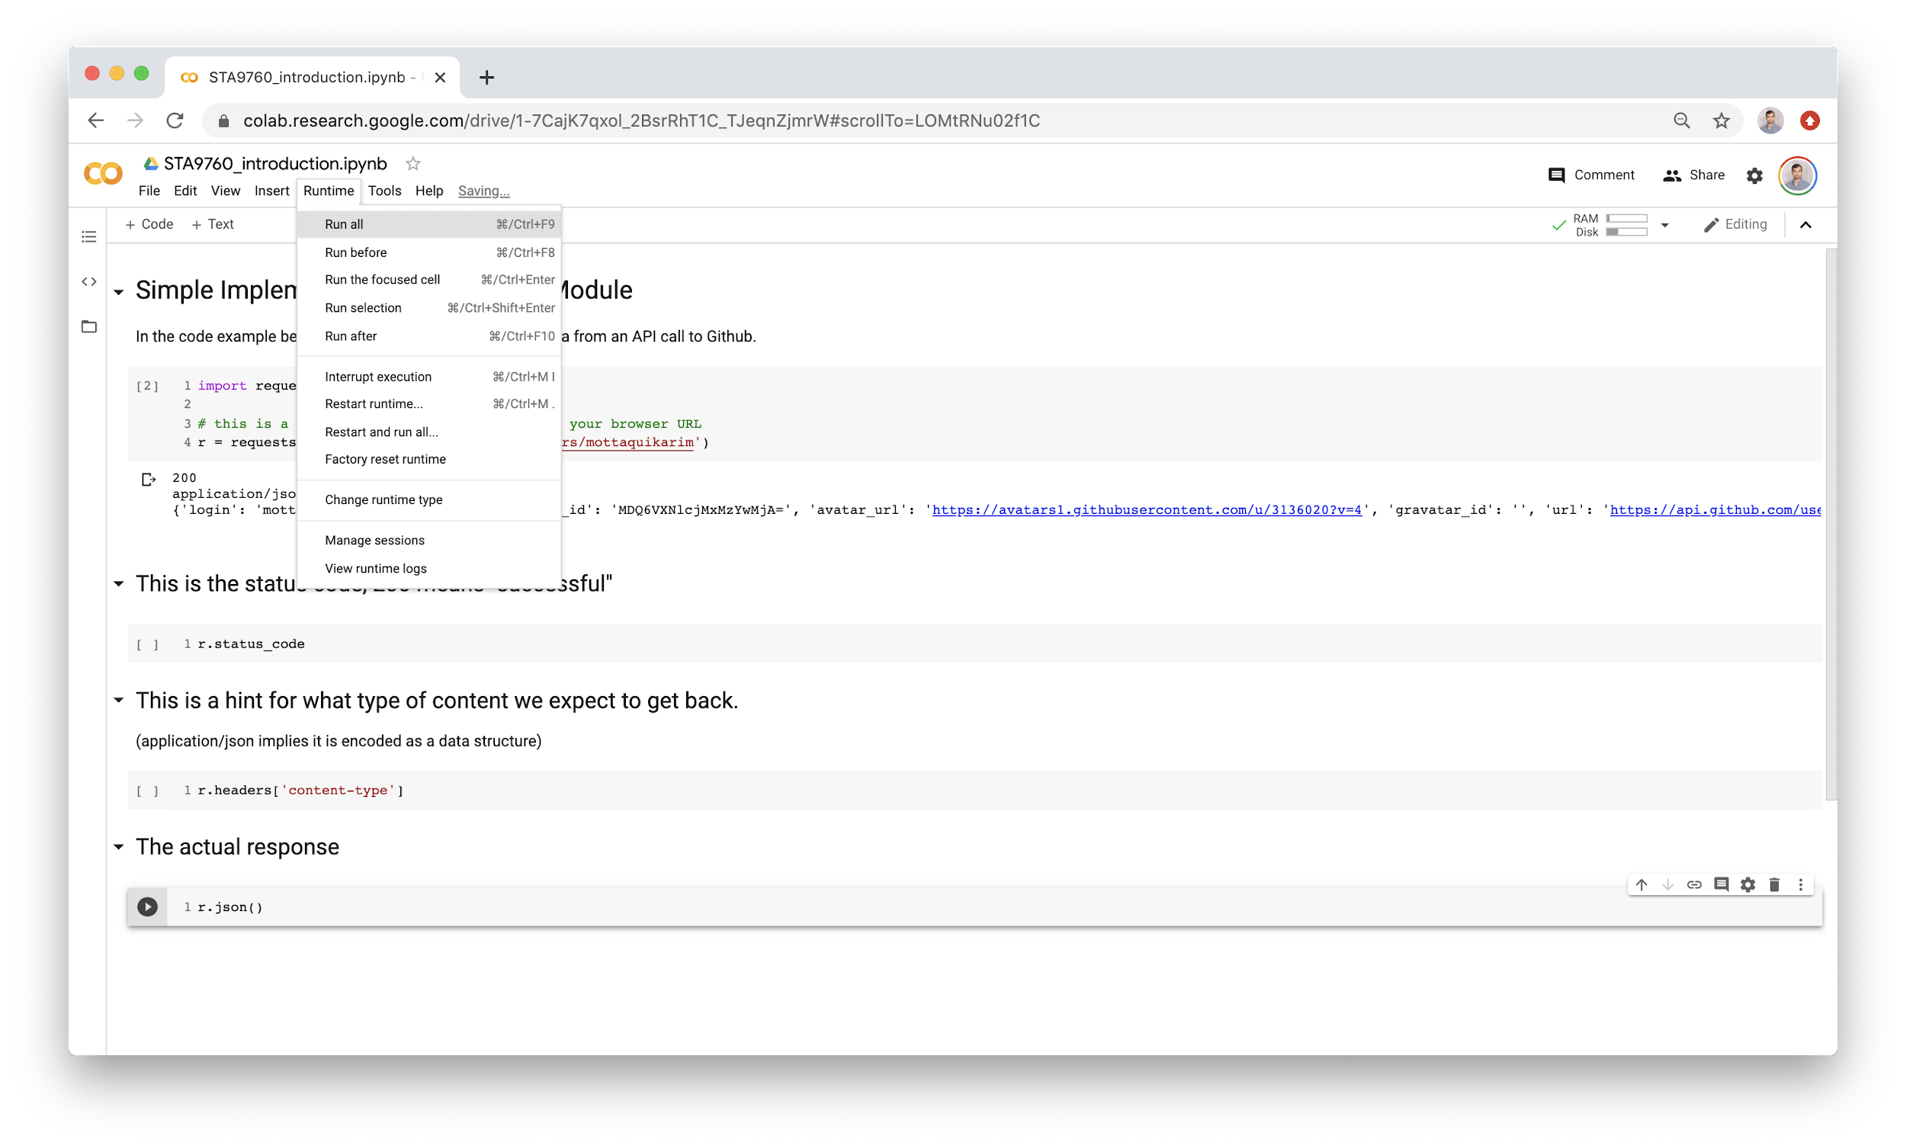

Also note that we are able to run *all* cells should we choose to. With outputs defined we have: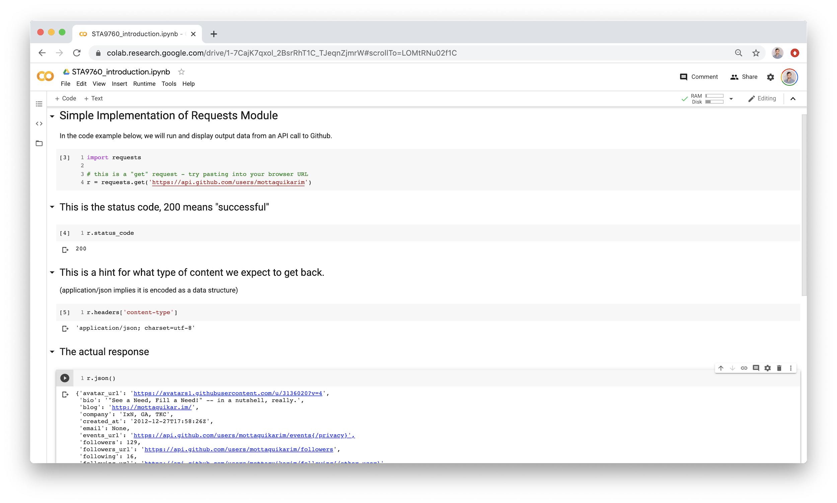

Note that the JSON response is already formatted for us within the cell output when we don’t wrap it in a **print** statement. It is also worth calling out that in Jupyter + Colab, the **last line** is always printed if it has a return value.

Finally, we have the option to “publish” our notebook to Github. To do this, we must perform a few steps first:

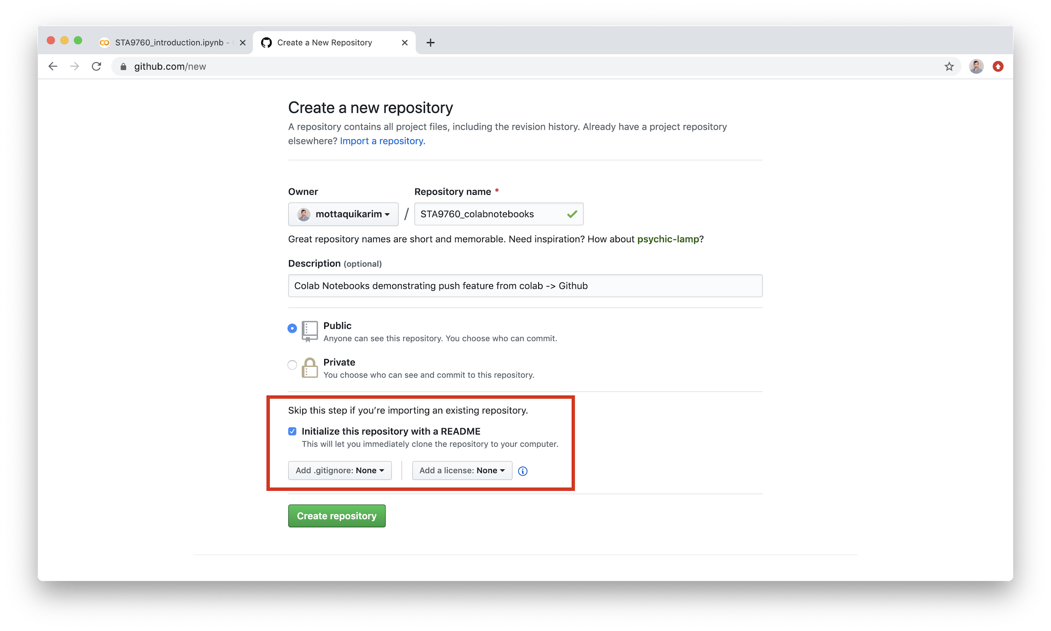

First, create a new github repository. **Make sure you initialize with a README as show in the red box.** Then:

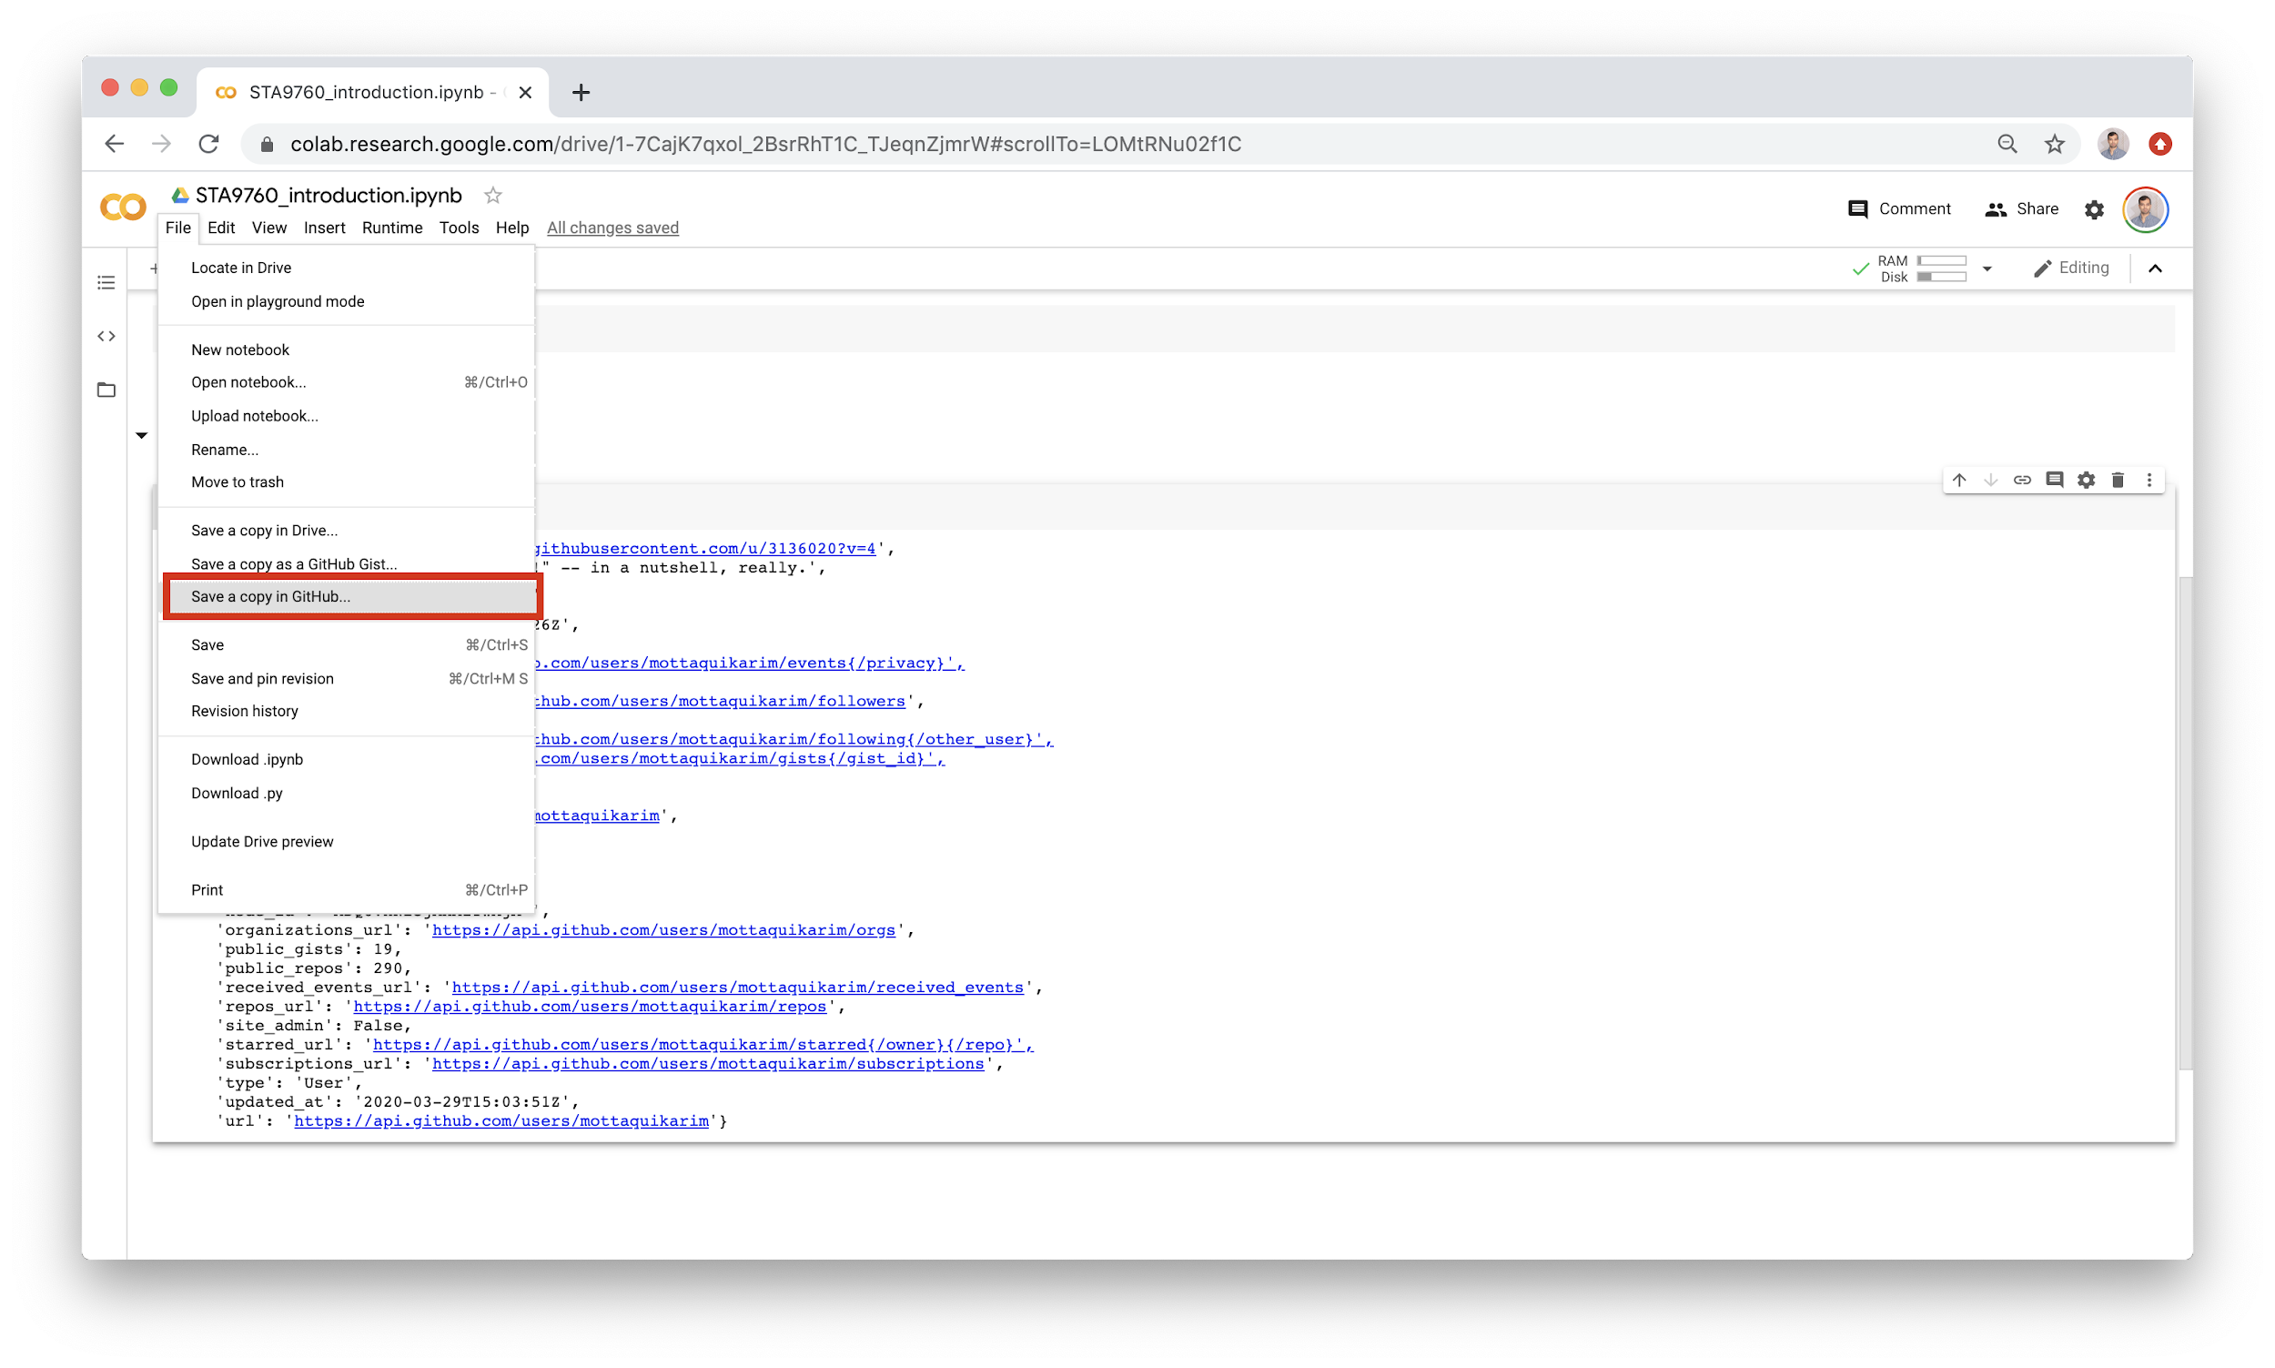

This will kick off a process where Colab requests access to Github on your behalf. You must authorize Colab to access your information in order to take advantage of this feature. Once you do, you will have the option to push your notebook (and other notebooks) to any of your github repositories.

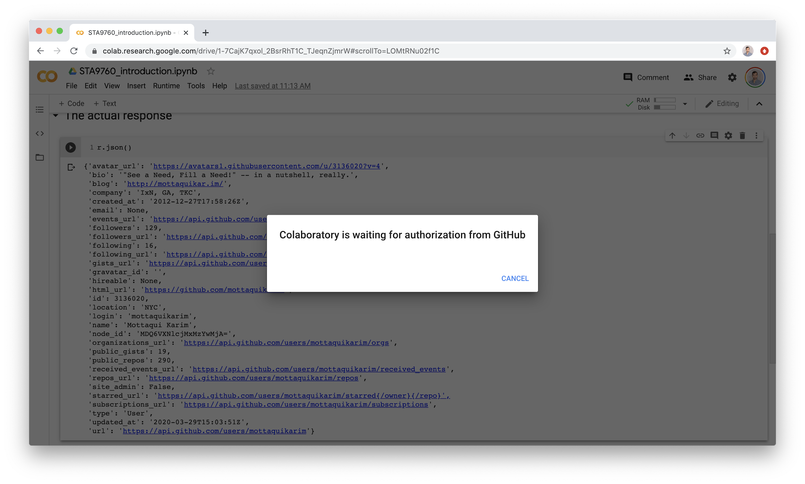

At this point a new window should open:

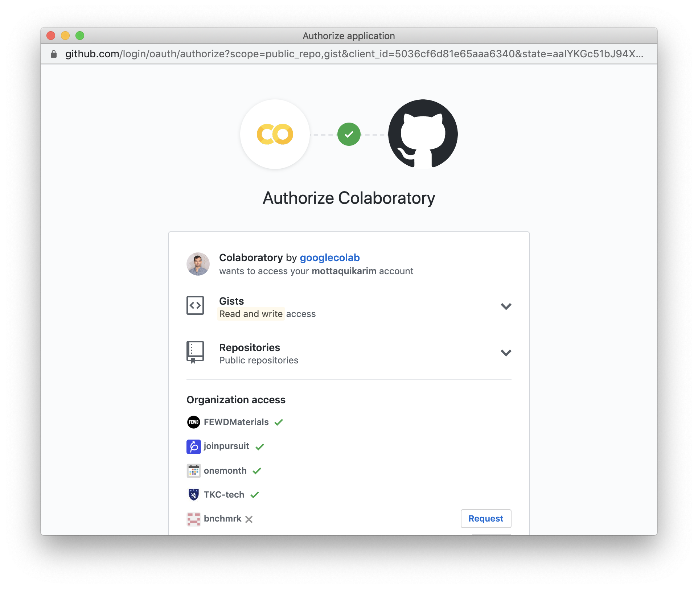

Once you authorize, you will be redirected to Colab:

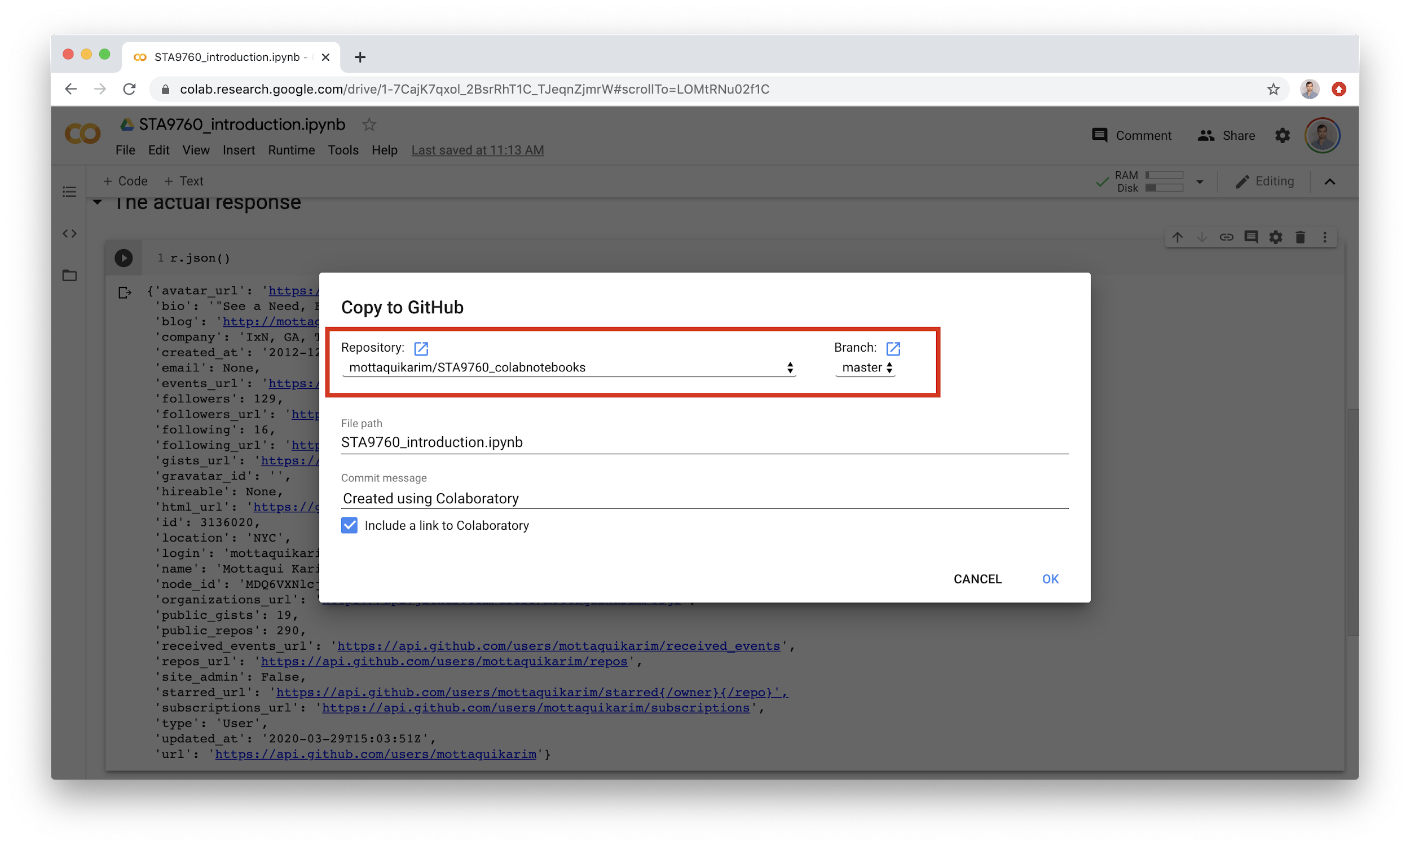

Pick the repo you created and hit OK. Github will open in a new tab and display your Colab notebook - but rendered with all the outputs!

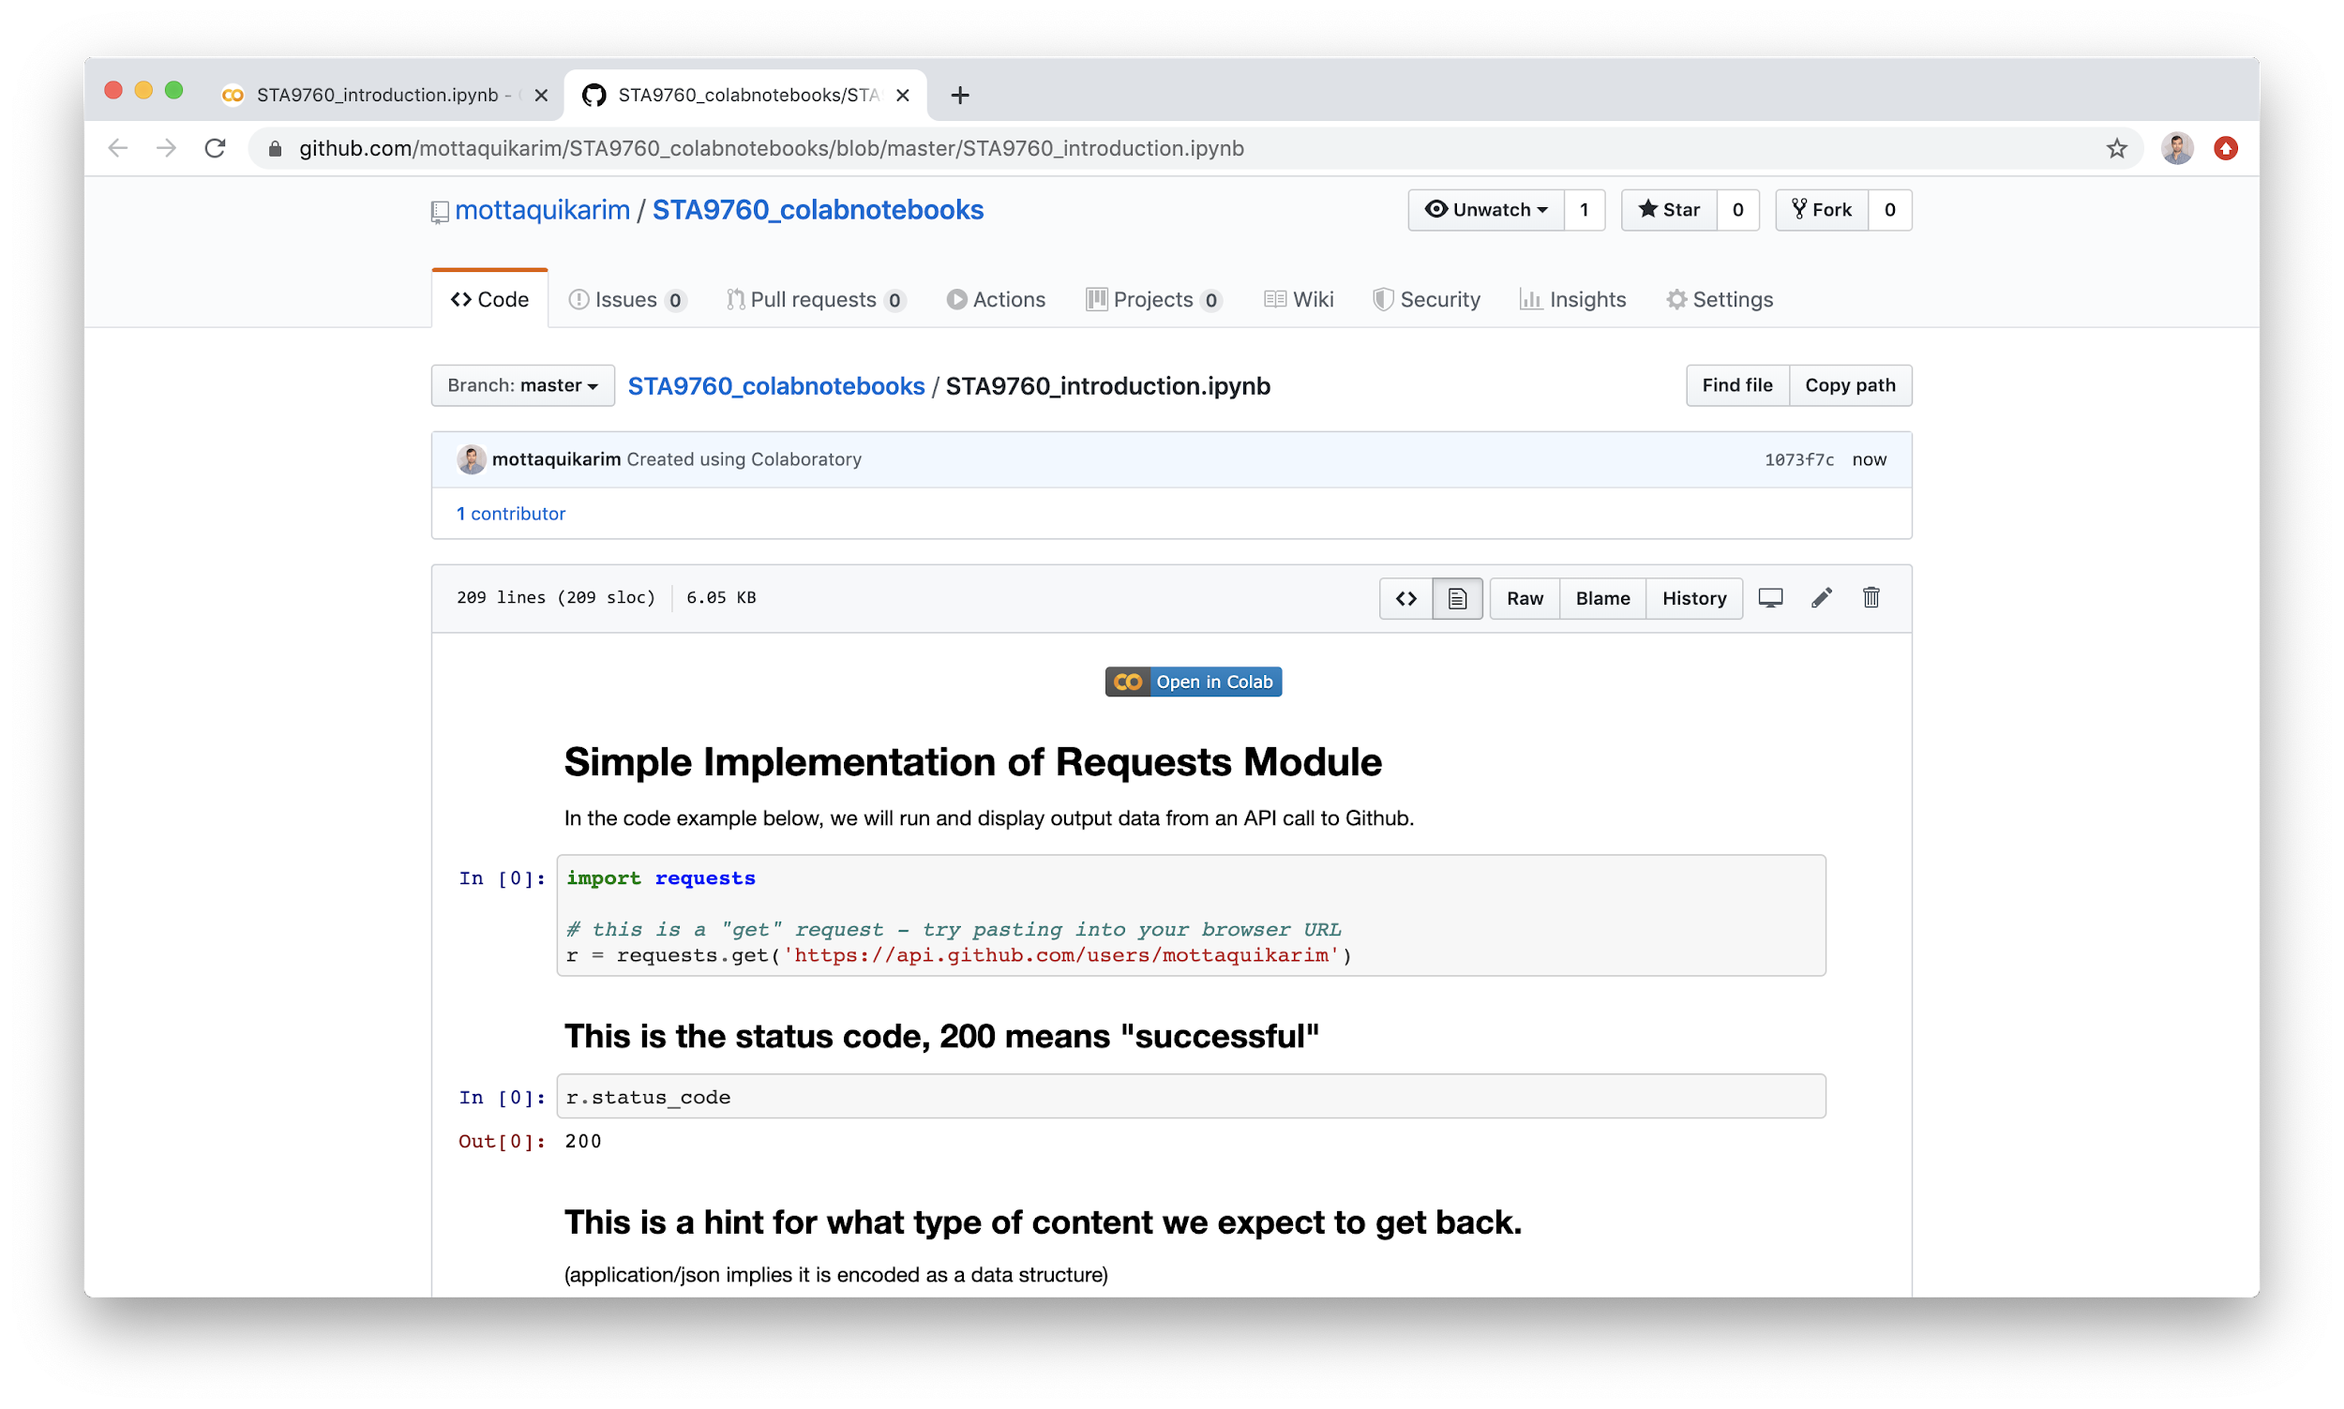

Additionally, note the “Open in Colab” button:

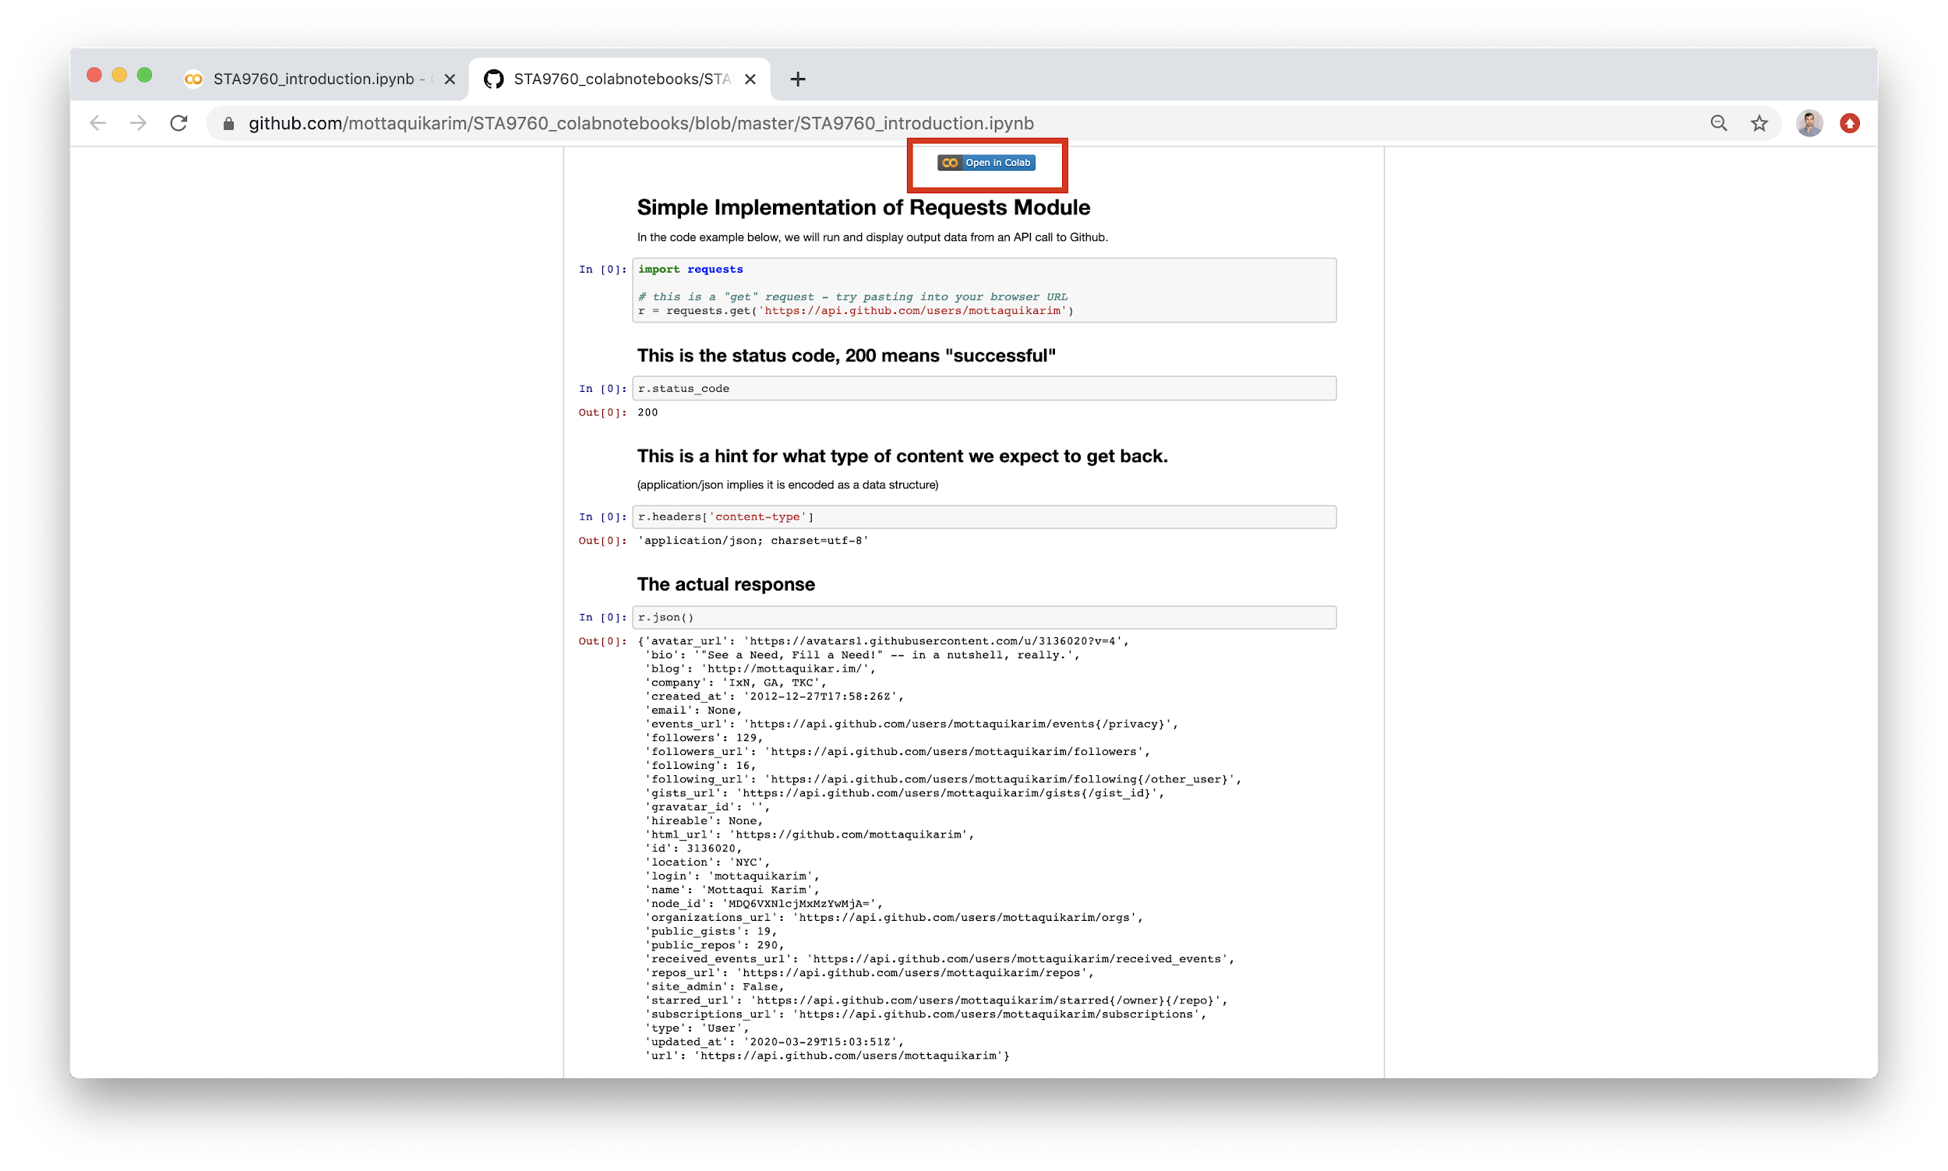

This actually allows anyone who comes across your notebook to open it for themselves in Colab, make a copy and make their own changes or otherwise run it as needed. Effectively, it allows other data scientists or engineers to leverage your code/analysis and reproduce or enhance your work.

Find the [**Notebook on Github here**](https://github.com/mottaquikarim/STA9760_colabnotebooks/blob/master/STA9760_introduction.ipynb)**.** Also, the Colab Notebook is available in our class google drive, under **Lecture 8**.

Before moving on, let’s look at an example of using Colab to extract some analysis from a data CSV file. In order to load a CSV file, it is possible to simply download it using the **requests** module. However, for datasets that are quite large, this is somewhat prohibitive as it may take a **long** time to download. Because Colab is a google product, we have the ability to download the dataset directly from Drive, using a small bit of code:

|  |
| --- |
| **from** google.colab **import** drive drive.mount('/content/gdrive') |

This opens up a dialog which requests access to Drive. If access is granted, all of your Drive will now be available to load as part of this Colab Notebook.

Below are some instructions via screenshot to illuminate the process:

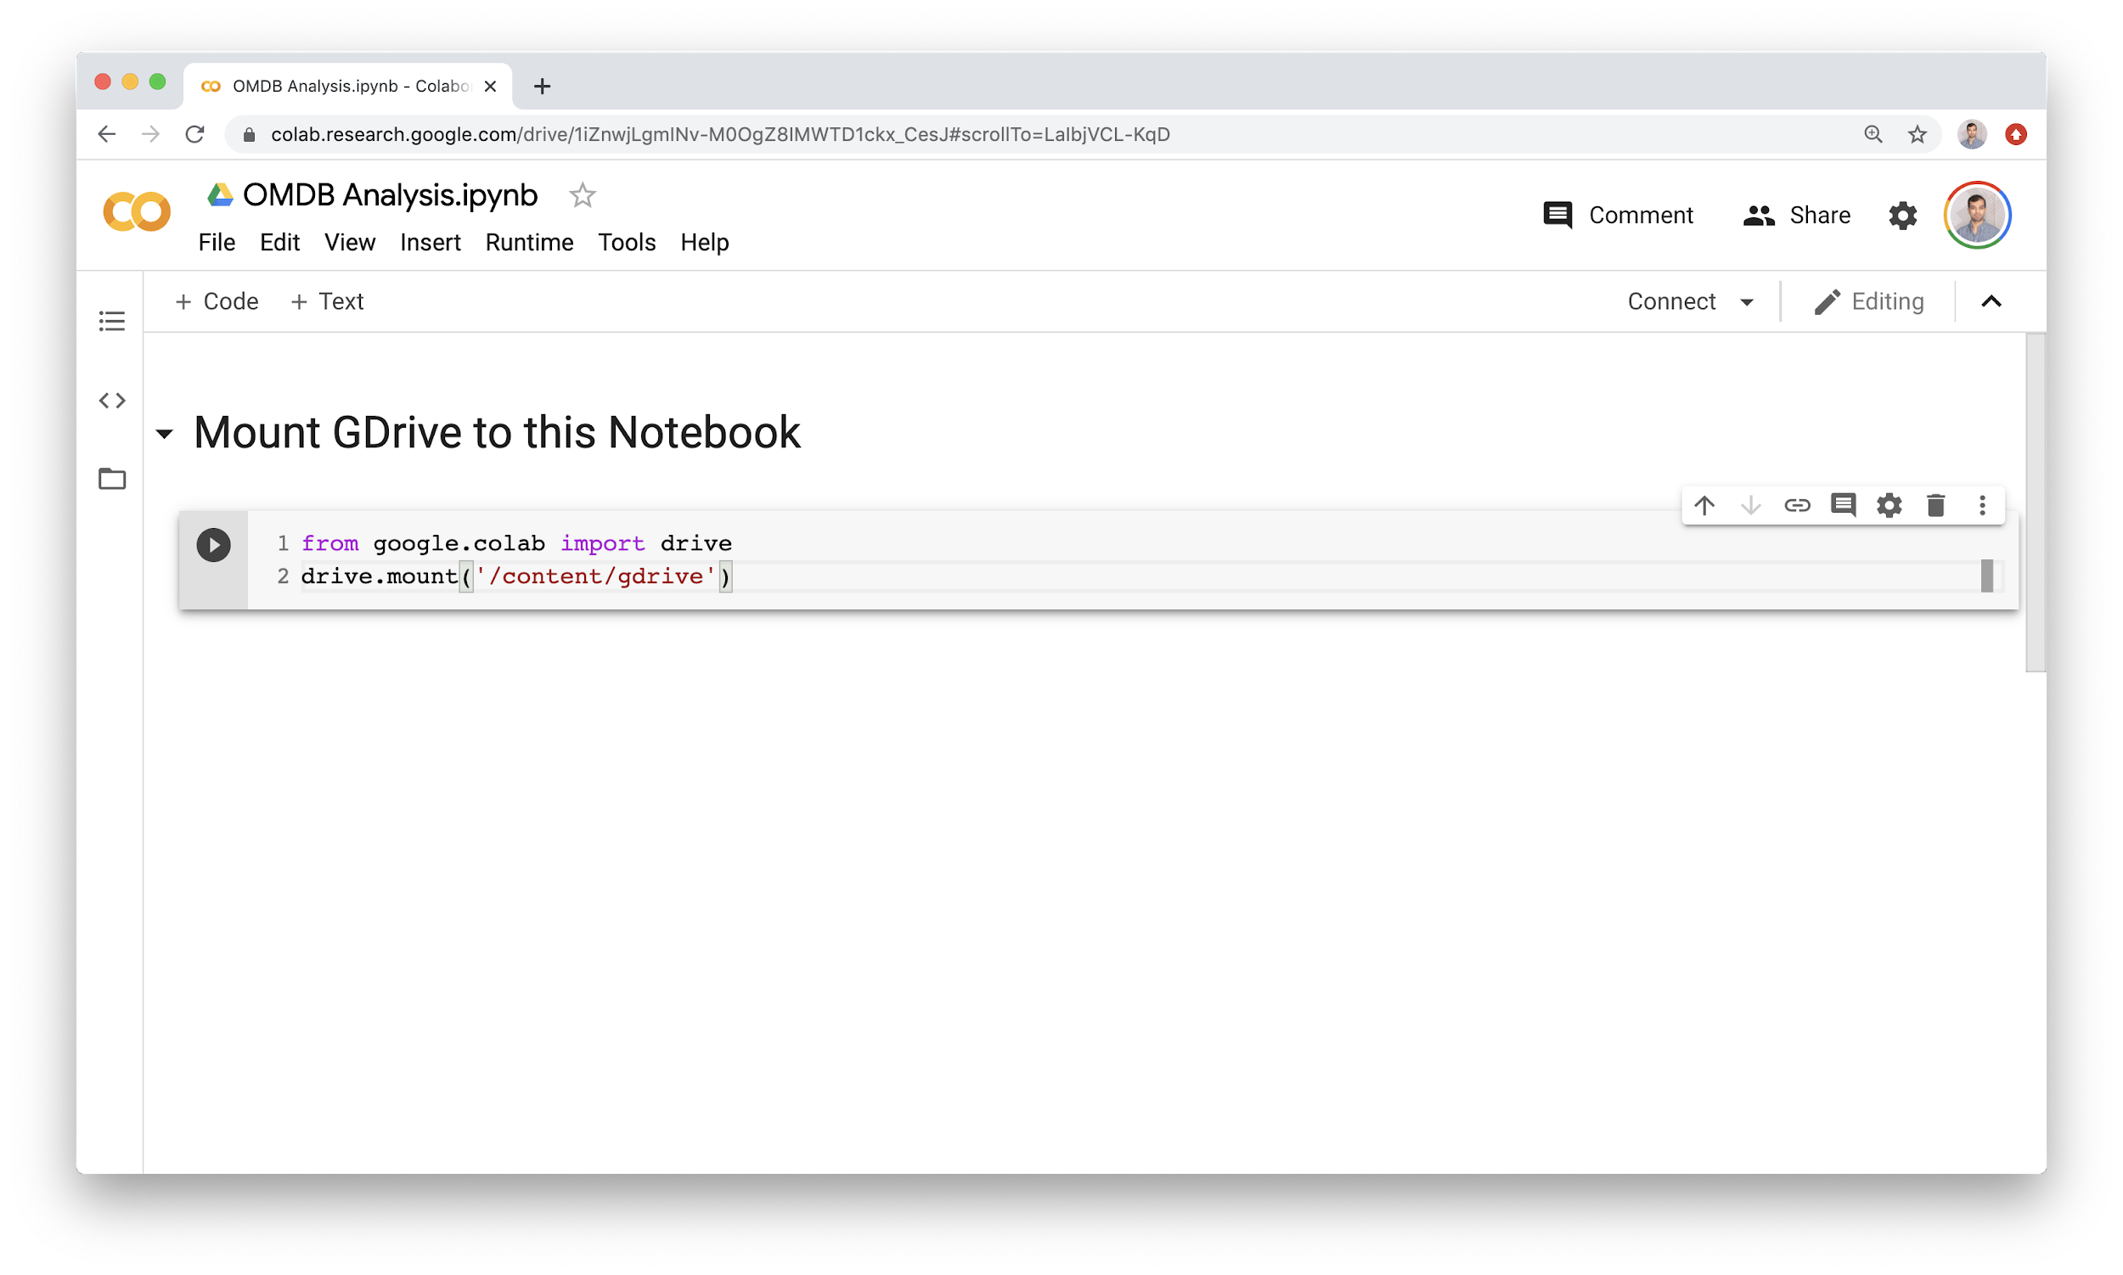

Running this code block leads to:

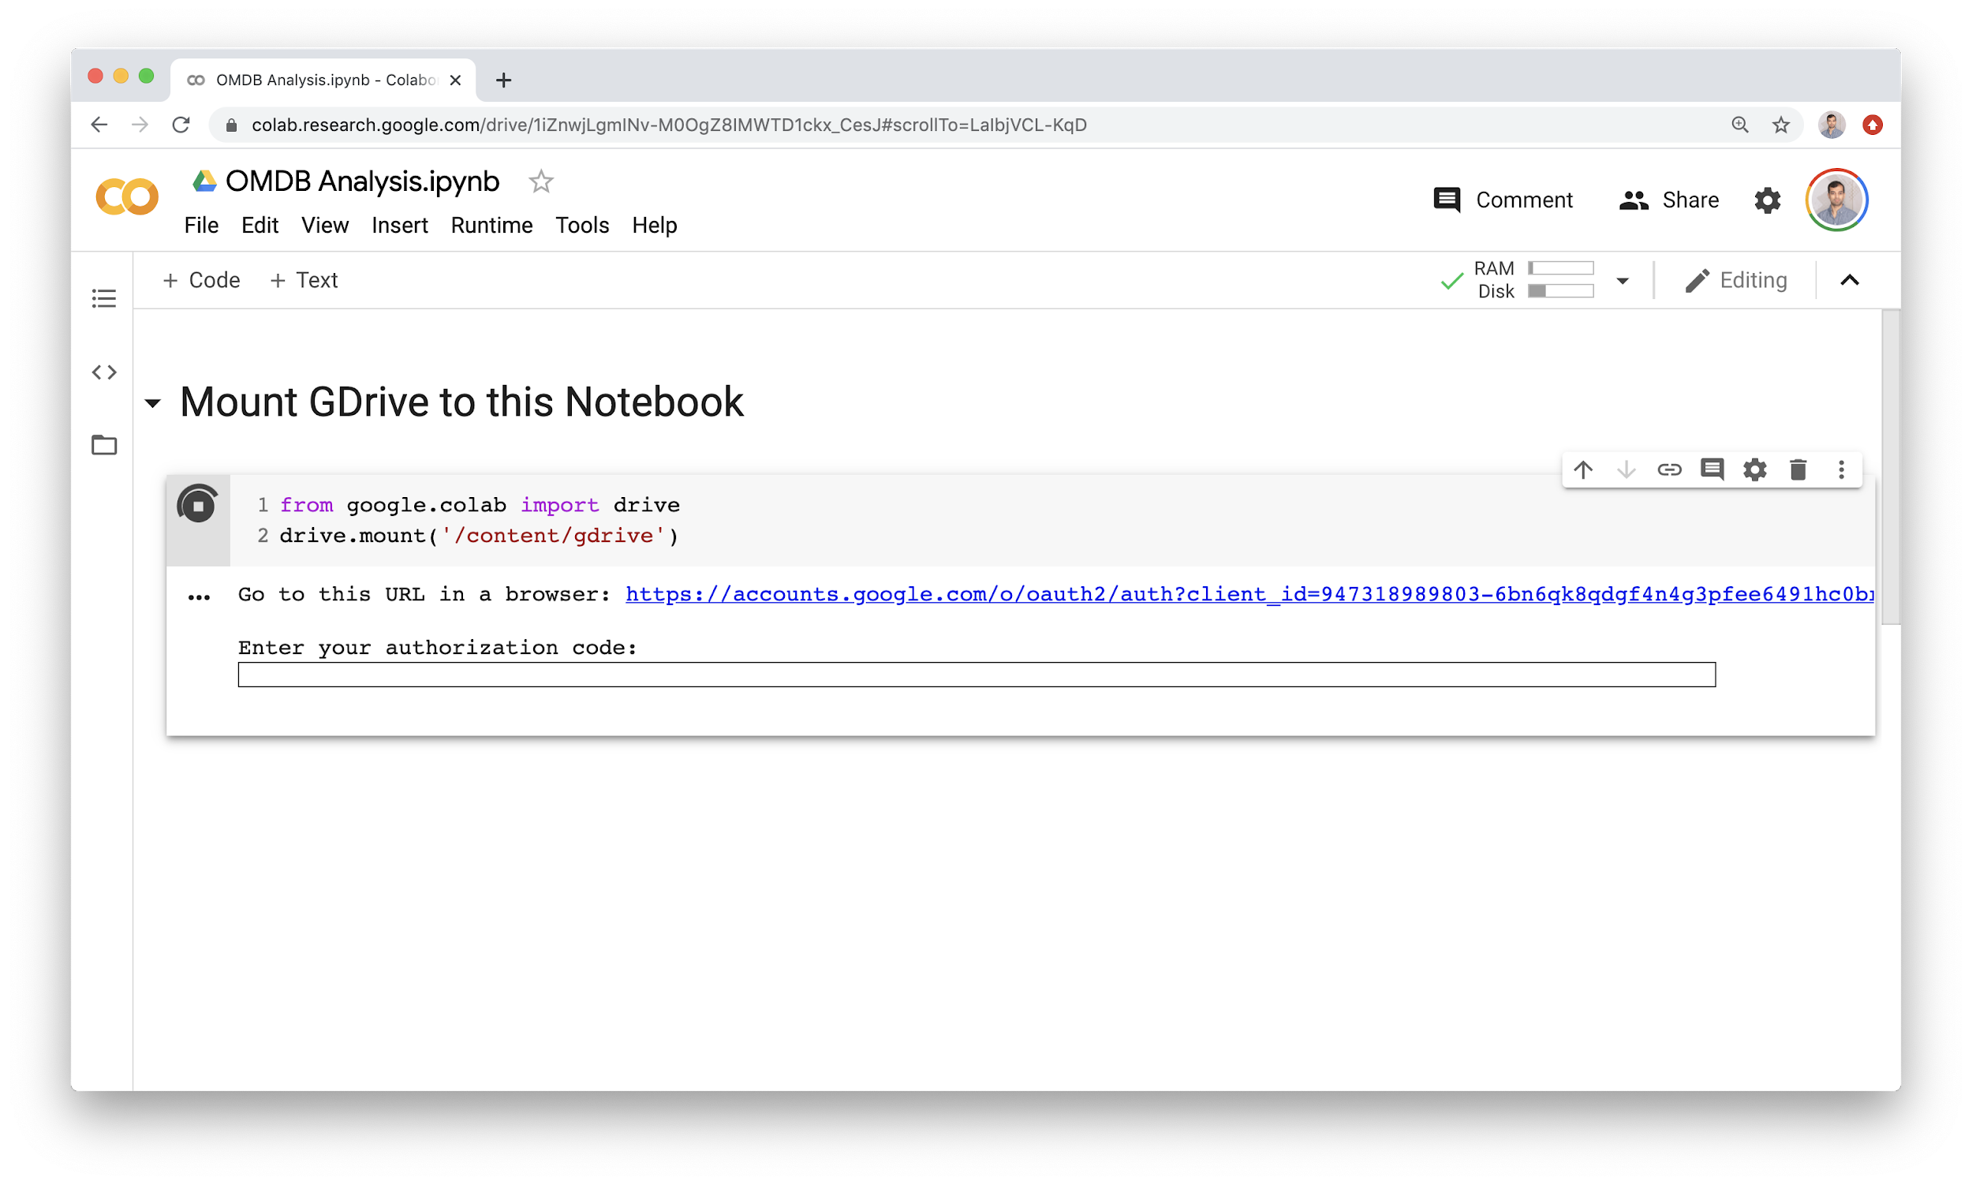

Click the link to start authorization process:

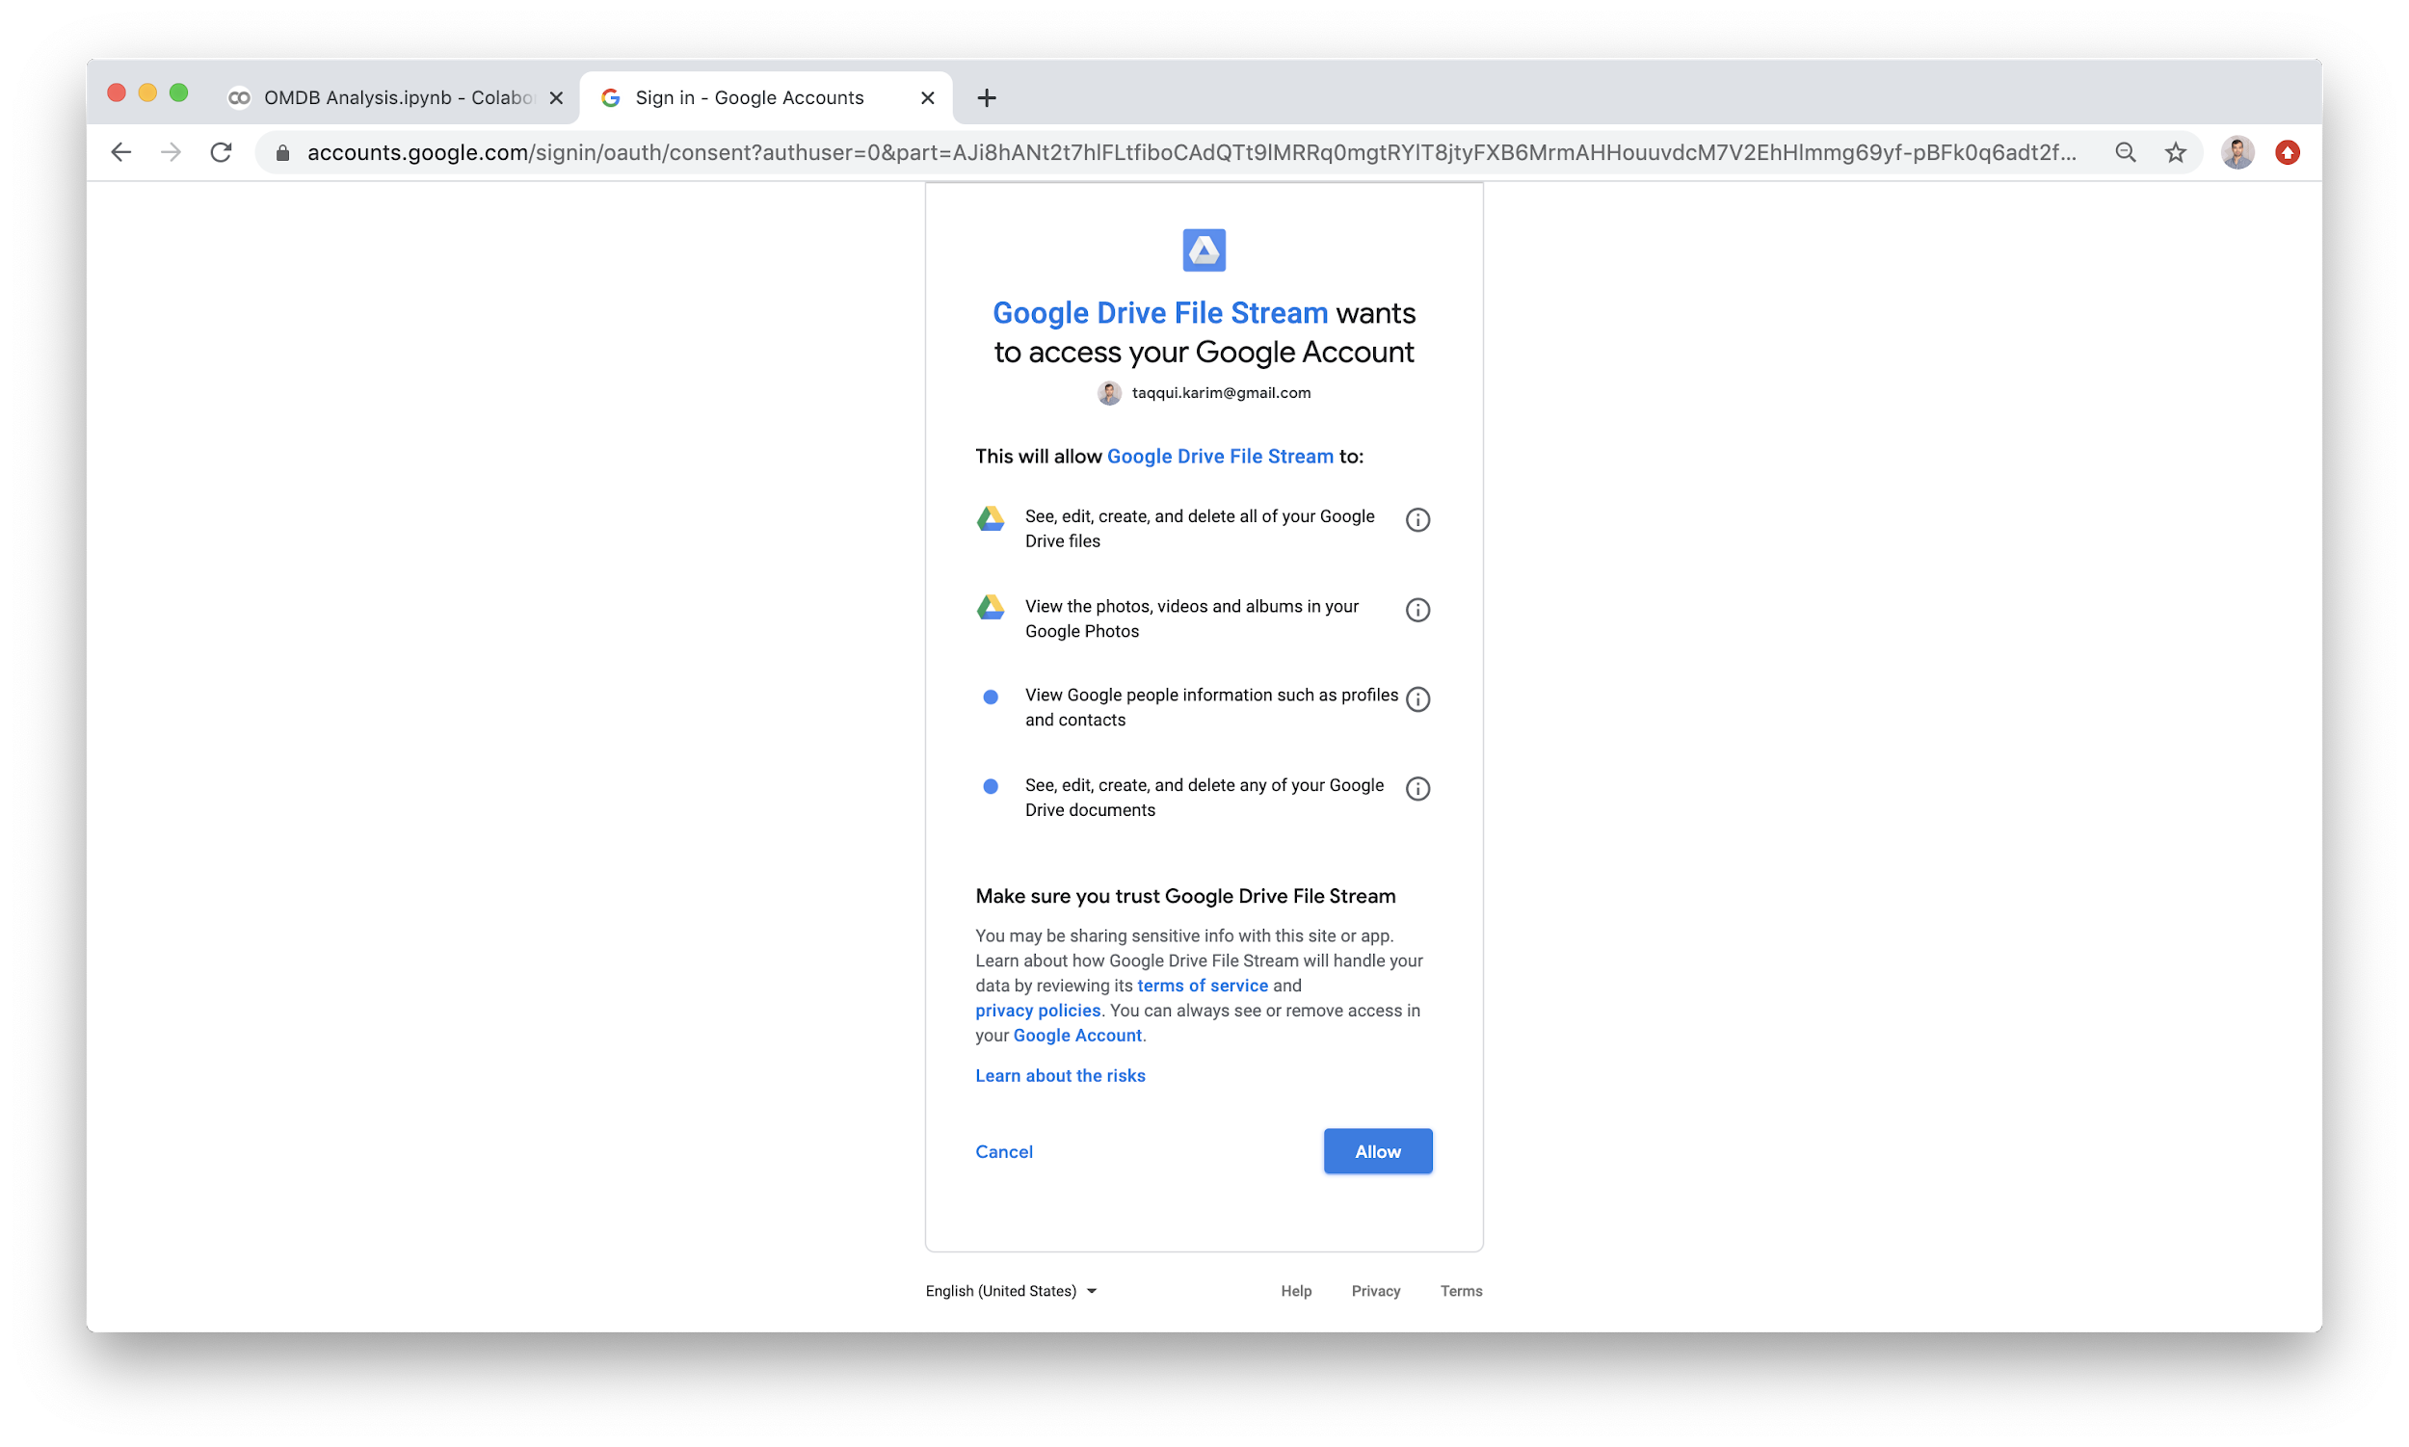

Once allowed, you will be direct to a dialog box with a code to copy and paste back to Colab:

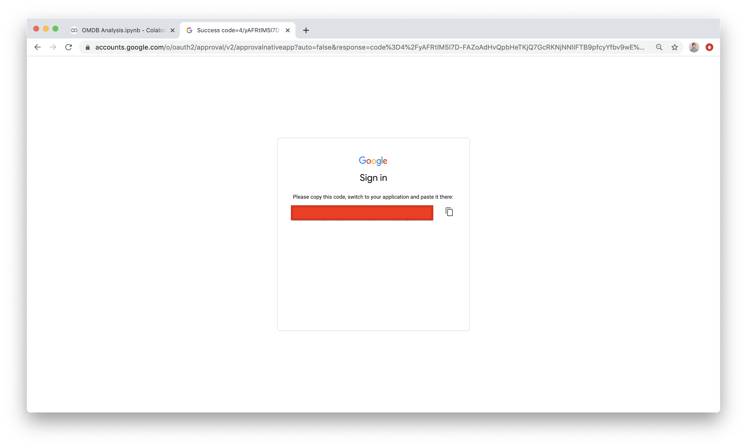

(Actual code blocked out for obvious reasons). Paste this back to Colab to continue:

### 

It takes a few minutes for authorization to complete. Once completed, you should see something like the following:

### 

At this point, you are able to load and use any of the files available on Drive:

# 

With drive loaded, you are able to do the following:

# 

Reproducing the code here for clarity:

|  |
| --- |
| df = pd.read_csv('/content/gdrive/My Drive/STA9760-202S/Lecture8/IMDB Analysis/omdb.csv')  df.head() |

In this case, the CSV file lives inside a folder called **`IMDB Analysis`.** The beauty of it is, if this folder is shared to the public, technically this should load for anyone. (This folder/project is available [here](https://drive.google.com/drive/folders/1q1WhBfbaj3UEz05RyBXqs6HlAIwdiNZJ) as part of our course materials).

Once completed, we end up with a notebook drawing data from a grdive folder that can be parsed with pandas and analyzed, as seen below:

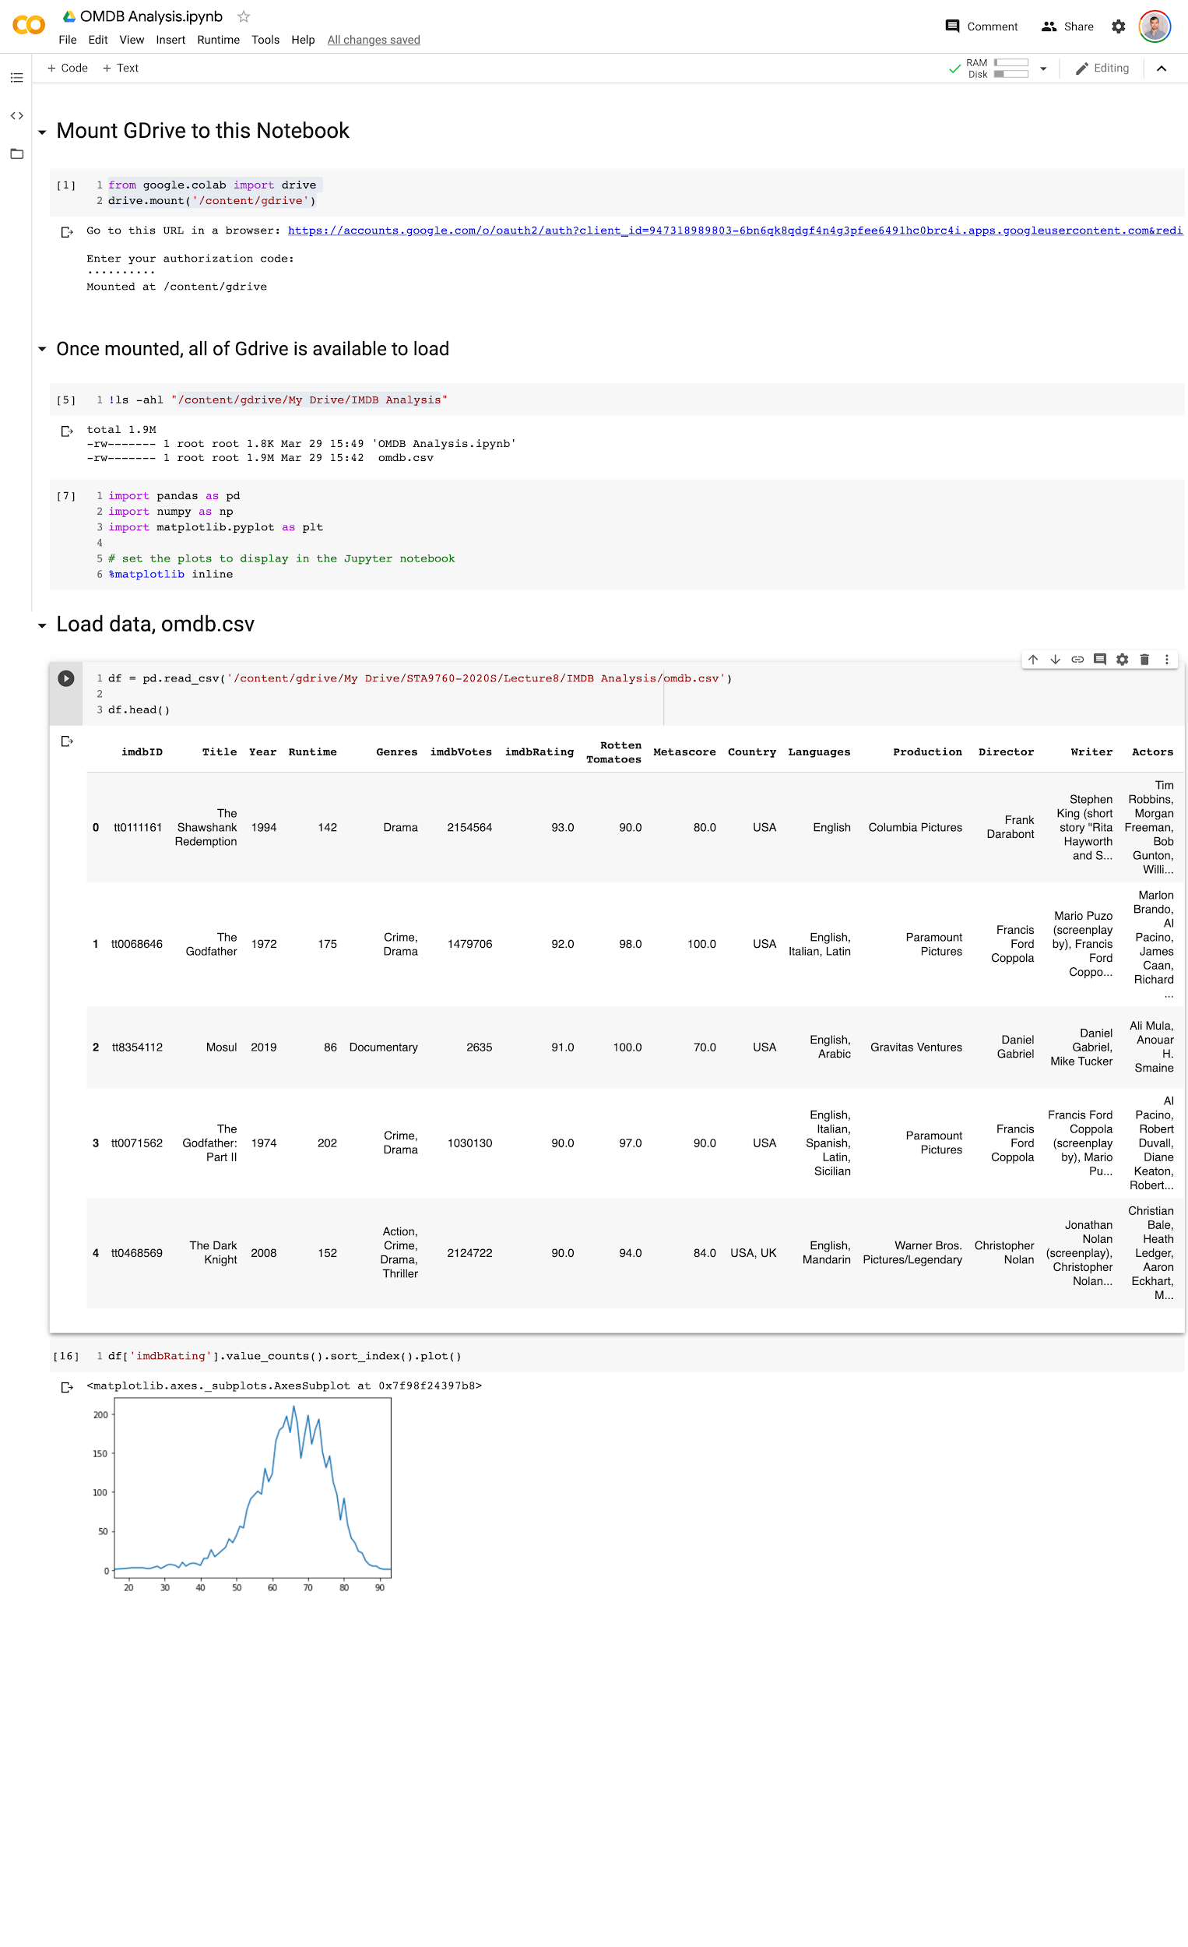

And exported to Github, we have:



 